ENGLISH
for
A΄ CLASS
LEVEL A2
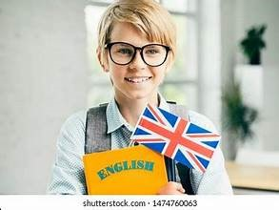

Cosmas Markis (EFL Teacher)
3rd Junior High School of Preveza

CONTENTS
UNIT 1: CELEBRATIONS & FESTIVALS……….p.1-6
UNIT 2: THE CITY & THE COUNTRYSIDE………………… p.7-12
UNIT 3: FOOD & COOKING………………………….. p.13-18
UNIT 4: TRAVEL & TRANSPORT …………………p.19-27
Unit 5: GET THE JOB DONE ………………………….p.29-38

UNIT 1: CELEBRATIONS AND FESTIVALS AROUND THE WORLD
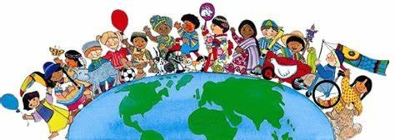
1. Do the following quiz to find out how much you know about celebrations and festivals around the world.
- On Thanksgiving Day, people in the USA eat
- turkey and pumpkin pie b. beef and corn c. chicken and pancakes
- In Halloween, people dress up in
- old costumes b. scary costumes c. historical costumes
- The most famous carnival in the world takes place in
- Paris b. Rio de Janeiro c. Los Angeles
- On Chinese New Year, decorations are
- red and blue b. blue and silver c. red and gold
- Valentine’s Day is celebrated in
- January b. February c. March
- In La Tomatina Festival in Spain, people throw each other
- water b. tomatoes c. rubbish
- On New Year’s Day, people around the world let off
- fireworks b. lanterns c. kites
- On Christmas Eve, children sing
- happy songs b. hymns c. carols
- Ramadan is the greatest celebration for
- Muslims b. Buddhists c. Jews
- On Easter Day Greeks eat
- lamb-on-the-spit b. roast chicken c. pork-on-the-spit
2. Make questions for the 10 quiz sentences. Be careful of the question forms.
(QUESTION WORD) + AUXILLIARY VERB + WHO + VERB + REST SENTENCE
Who/What/Which/ do / does / is / are
When/Where/How…
e.g. Do the Chinese celebrate New Year‘s Day?
When do the Chinese celebrate New Year’s Day?
How do the Chinese celebrate New Year’s Day?
- What do people in the USA eat on Thanksgiving Day?
- ……………………………………………………………………………………………………………………………………………………….
- ……………………………………………………………………………………………………………………………………………………….
- ……………………………………………………………………………………………………………………………………………………….
- ………………………………………………………………………………………………………………………………………………………..
- ………………………………………………………………………………………………………………………………………………………..
- …………………………………………………………………………………………………………………………………………………………
- ………………………………………………………………………………………………………………………………………………………..
- …………………………………………………………………………………………………………………………………………………………
- ……………………………………………………………………………………………………………………………………………………….. 1
Let’s Learn: How the world celebrates!
All around the world people love to celebrate. Celebrations and festivals are connected with tradition, religion or history. Some celebrations include food, music and dancing, and others decorations, lights and fireworks. In lots of celebrations people dress up in special costumes and make parades. In all cases, celebrations and festivals are a wonderful chance for people to get together and have fun.
- Match the words with the pictures.
lanterns fireworks candle parade float hot-air balloon trick-or-treat calendar
12 3 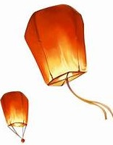4 5  6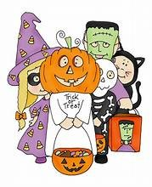7 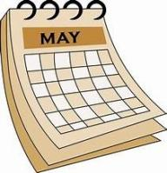8 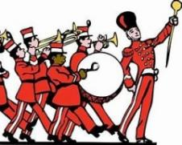
- Let’s read about some of the most popular celebrations around the world and do the tasks that follow.
Halloween

Halloween is a traditional celebration that began in Europe hundreds of years ago. At that time, some people believed that ghosts of the dead visited the living. Nowadays, it is a special day in several countries around the world, but it is most popular in Canada and the United States. It’s always on the same date every year: October 31.
In the evening of October 31, children wear scary costumes. They dress up as ghosts, animals, monsters or vampires. They can be very funny or they can be quite scary. The costumes often include a face mask or some face painting. For example, at Halloween you can see a dinosaur or an elephant, a witch with a tall black hat, or maybe a ghost. Children go from house to house and ask for sweets by saying, “Trick or treat?” They also play traditional games like “Bobbing for apples”. Older kids and adults dress up and go to Halloween parties. Jack - o’ lanterns are very common during this time. They are pumpkins with lights inside and faces cut into them. A lot of people like to put them in their windows. Most people, both young and old, have a lot of fun at Halloween. “Happy Halloween” everyone!
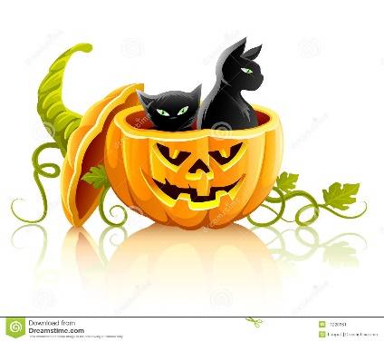
Circle T (True) or F (False).
1. Halloween is a relatively new celebration. T F
2. It is on the last day of October. T F
3. Only children wear costumes. T F
4. Children go around houses asking for lanterns. T F
5 . Faces are carved into pumpkins. T F
6. Not all costumes are scary. T F
7 . People of all ages enjoy Halloween. T F
The Chinese New Year
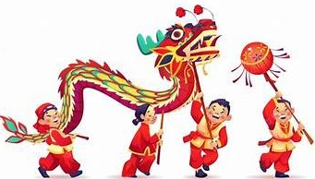
The date of the Chinese New Year depends on the moon, but it’s usually in January or February and it’s a big celebration. Everyone gets outside to watch the spectacular parades and the awesome fireworks that light up the sky. There are red decorations in every house and red dragons dancing in the streets.
The Chinese New Year is a time to make everything fresh and new. People clean up their houses, wear new clothes and get a haircut to clean away bad luck. They also hang up red and gold decorations. They make handmade calendars and wish each other good luck and happiness.
Complete the sentences.
- Chinese New year is ................................................. 4. People want to clean away ...................................
- You can see ............................................................ 5. They make ...........................................................
- Every house has .................................................. 6. They wish each other ............................................ 2

Carnival in Brazil
The world-famous Carnival in Rio de Janeiro, Brazil is a stunning celebration. It usually takes place at the end of February and lasts for four days. All the streets come alive with parties, singing and dancing. The carnival attracts thousands of people from all over the world and gives them the chance to learn about the rich culture of Brazil.
The Samba school parade is the most popular event. About 3,000 performers with dazzling costumes dance in the parade. There are also hundreds of colourful floats. They all dance and have fun to the sound of samba music. In the end, the best Samba School wins the competition for the title of the Carnival Champion.
Complete with the correct word.
- The Carnival in Rio de Janeiro, Brazil is a ........................................... celebration .
- Carnival in Rio ........................................ for four days.
- Tourists have the .......................................to learn about the rich culture of Brazil.
- About 3,000 performers with ...................................... costumes dance in the parade.
- The best Samba School ...................................... the competition.


Thanksgiving Day
Thanksgiving Day is a national holiday in the USA. It is on the fourth Thursday in November.
Thanksgiving is a time when families get together and give thanks for all the good things in their lives. People eat a traditional dinner, roast turkey and pumpkin pie for dessert. In New Year there is a big parade. It’s called Macy’s Thanksgiving Day parade. At the parade you can see floats, marching bands and clowns. All over the USA is an important celebration.
Put the words in the correct order to make sentences.
- is / Thanksgiving Day / a / holiday / national
- November / takes / in / It / place
- celebration / It / important / an / family / is
- in / There / a / New York / parade / big / is
- pumpkin / turkey / for / eat / pie / and / roast / dessert / People
- and / floats / see / at / You / can / parade / the / clowns

LET’S WATCH: DIA DE LOS MUERTOS (THE DAY OF THE DEAD)
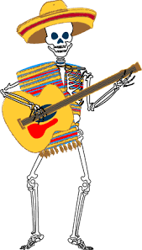
Watch the following video about the popular Mexican festival “The Day of the Dead”. Then watch again and complete the missing words
https://www.youtube.com/watch?v=OMzSsTrs4Gs
- The Day of the dead is a festival to honour people who are no longer ………………………………….
- It is celebrated in South ……………………………………
- The first day is ……………………………………………………
- On the second and third day the …………………………………… of the dead adults and children visit earth.
- The history of the celebration dates back ……………………………………………………….
- Surprisingly, the day of the dead is not a ……………………………………………… time.
- The Day of the Dead is a fiesta of flowers, food, …..……………., …….…….………, prayers and …….…………..
- People dress up as …………………………………………….
- They light ………………………………………. during the afternoon.
- During the day the eat a special …………………………………..
 3
Let’s Practise: PRESENT SIMPLE & CONTINUOUS
A. Circle the correct answer. Underline the time expressions that helped you decide.
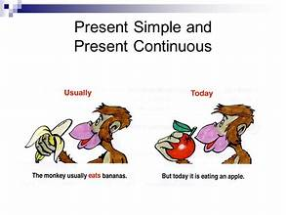
1. Look! Thomas is bringing / brings his little sister to class.
2. My older sister is often listening / often listens to pop music.
3. We are writing / write an exercise now.
4. Mmmm! Mum is making / makes a cake.
5. Our teacher is giving / gives us a test every month.
6. Listen! Dad is reading / reads a story to Ricky.
7. Mr. Michael usually is growing / grows roses in his garden.
8. They are building / build a new house on the hill now.
9. Maria is drinking / drinks milk every morning.
10. Look! Nick is running / runs down the hill.

B. Complete the following sentences with Present Simple or Present Continuous:
1. Listen! Jane ………………………………..…… (sing) again. She often …………………….. (sing) this song.
2. My father ………………………………..…(have) a lot of work to do every weekend.
3. The girls ………………………………………….. (not / talk) now. All of them …………………..……………… (watch) a film.
4. …………………… you …………………….. (like) watching TV?
5. He …………………….……….. (usually / leave) at 9:00 o’clock, but this morning he ………………………….. (leave) home late.
6. I ………………………………. (visit) my grandparents every Friday. My sister ……………………………. (not /often / visit) them.
7. The boys ……………………………….. (swim) in the pool now but they ………………………………… (usually / swim) in the sea.
8. She ………………………….………….(write) a letter to her pen-friend at the moment.
9. They ………………………….. (sometimes / have) lunch at work, but today they …………………………. (eat) at a restaurant.
10. She can’t talk to you. She ………………..…………………………. (have) a shower.
11. “Where …………………………… Alex ………………………… (live)?“In France.”
12. Tom …………………………………………… (like ) making model planes.
13. The children ……………………...………… (play) the piano and ………….……..…………… (sing) a song at the moment.
14. My mother ……………………………..………………. (always / cook) in the morning.
15. What ………………………….…………………… (you / usually / do) at weekends?
16. Jane ………………………….…………… (give) a party today because it ………………………… (be) her birthday.
17. The lesson ………………………………..… (start) at 9 o’clock every morning.

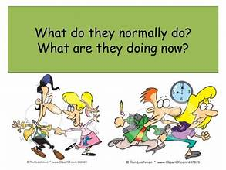
Β. Ask questions for the underlined words:
1. …………………………………………………………………………………… ?
George often has a bath.
2. …………………………………………………………………………………… ?
Mike eats corn-flakes for breakfast every morning.
3. …………………………………………………………………………………… ?
The teacher is writing some examples on the board.
4. …………………………………………………………………………………… ?
Tom is watching a film now.
5. …………………………………………………………………………………… ?
My parents never sleep late.
6. …………………………………………………………………………………… ?
Peter and Rob go to school by bus.
7. …………………………………………………………………………………….?
Sam is doing his homework in his room.
8. …………………………………………………………………………………… ?
I read two books every month.
9. …………………………………………………………………………………… ?
No, Sally isn’t writing a letter now. 4
PREPOSITIONS OF TIME
at on in
6:30 Monday April the morning
noon / midnight Thursday morning winter the afternoon
the moment / present Christmas day 2021 the evening
Christmas / Easter October 23rd the 1980s 10 minutes
the weekend my birthday the 20th century
1.GAME: One student says a time expression and the other repeats it with the correct preposition.
eg. STUDENT 1: November STUDENT 2: In November

2. Complete with at, in, on.
1. ...... night 7. ...... Tuesday 13. ......the end of th school year
2. ...... Christmas Day 8. ...... 8th June 14. ...... the morning
3. ...... 17.30 9. ...... weekends 15. ...... half past two
4. ...... May 10....... Tuesday afternoon 16. ........ twenty minutes
5. ...... summer 11. ...... 1996 17. .......... this afternoon
6. ...... the evening 12. ...... the 15th century 18. ............ the moment

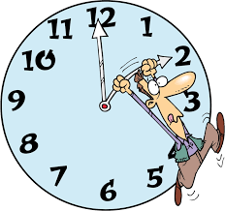
3. Write at, in, on or –
1. We often go on holiday ......... summer.
2. I saw Brenda .......... last week.
3. Do you want to go to the cinema .......... the weekend?
4. James isn´t here .......... the moment.
5. Are you coming ........... Tuesday morning?
6. See you ............. next Friday!
7. I´m almost ready. We can go out ........... 10 minutes.
8. The film starts ........... 7.30.
9. The factory opened ............ 2002.
10. We live ……..... the 21st century.
11. Her birthday is ............ 22nd May.
12. Sally met her boyfriend ............ last summer.
13. We have lunch ............. midday.
14. They´re coming ……...... the afternoon.
15. His friends got married ............ New Year´s Eve.

4. If the preposition is wrong, write the correct one in the blank. If it´s correct, write ok.

1. My birthday is in 23rd May. ......
2. The train leaves in 10 minutes. ......
3. It doesn´t rain much on winter. ......
4. The film starts at 10 o´clock. ......
5. The plane arrives at Tuesday. ......
6. We have lessons on Monday morning. ......
7. In Christmas Day the shops close. ......
8. I play tennis in the weekend. ......
9. We usually go swimming at the summer. ..........
10. Leonardo da Vinci lived in the 15th century. ........
11. Dad was born at 1982. ........
12. I have a lot of homework at present. ..........
13. We ll meet at the evening. ............
14. Sam goes to bed in about midnight. ............
15. There were no mobiles back on the 1980s. ...........
5

Let’s Write: an e-mail to describe a celebration
A. Read the mail that Keith sent to Pierre, his French friend and and match each paragraph/part to what it does:
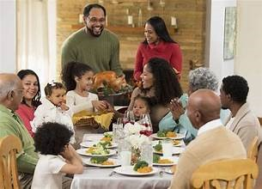
Dear Pierre,
How are you? I’m writing to tell you that it’s Thanksgiving today here in the USA and I‘m really excited because it’s my favourite celebration.
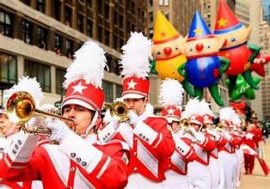
Thanksgiving is the biggest family celebration in the USA. We celebrate it at the end of November. It began when the first settlers wanted to give thanks for the corn harvests of the year, but today it is a time when we give thanks for everything we have. On this day, people who live far away usually travel long distances to be with their families and friends and enjoy a traditional meal of turkey and cranberry sauce. And of course, the delicious pumpkin pie for dessert. So, now I’m in my best clothes waiting for my aunt, uncle and cousins to arrive and have dinner together.
There is also a large parade in New York on this day and millions of people go to see it every year. There are marching bands, colourful costumes and dazzling floats. People dance, sing and throw confetti. We are all going to see it after dinner. We never miss it.
Anyway, my cousins are arriving soon, so I have to go. I’m sure we’ll have a wonderful time this year, too. I’ll write back soon and tell you all about it.
Bye for now,
Keith
Email Section | What does it do?
1. Greeting & Reason for writing | A. Describes special events, parades, activities, or traditions.
2. Paragraph 1 (Main Details) | B. Says goodbye and promises to write again soon.
3. Paragraph 2 (Activities & Atmosphere) | C. Says hello, names the celebration, and says when/why people celebrate it. Includes food details!
4. Paragraph 3 & Sign-off | D. Greets the friend, asks how they are, and states why they are writing.

B. Choose ONE celebration below and write a mail to a friend from another country to describe it. Use the clues and follow the plan to help you. (80-120 words)

Christmas in Greece

- When: December 25th
- Decorations: Decorate a Christmas tree / traditional wooden boat
- Music & Customs: Sing Christmas carols / Christmas Eve
- Food & Treats: Eat roasted pork, melomakarona (honey cookies), and kourabiedes (almond sugar cookies)
- Family: Gather / big family lunch/ exchange gifts / play board games
- Atmosphere: Streets full of fairy lights, cheerful music, and festive cheer

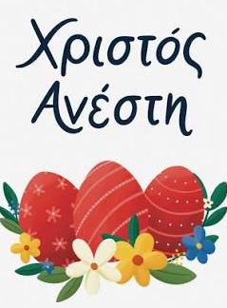
Greek Orthodox Easter
- When: Spring (April or May)
- Customs: Hold glowing white candles (lambades) / Holy Saturday
- Traditions: Crack red-dyed eggs / say "Christ has Risen!"
- Food: Eat delicious magiritsa soup / lamb on the spit / Easter Sunday
- Sweets: Bake sweet Easter bread (tsoureki)
- Activities: Gather in the yard / traditional dances / listen to music / relatives
- Atmosphere: Spring flowers, church bells ringing, and fireworks at midnight

6
UNIT 2: THE CITY & THE COUNTRYSIDE

Swapping Homes
Fay and Jill are taking part in a student exchange program. They are swapping families, houses and schools for a week. Fay lives in a block of flats in London and Jill lives on a farm in the north of England.

Jill’s diary
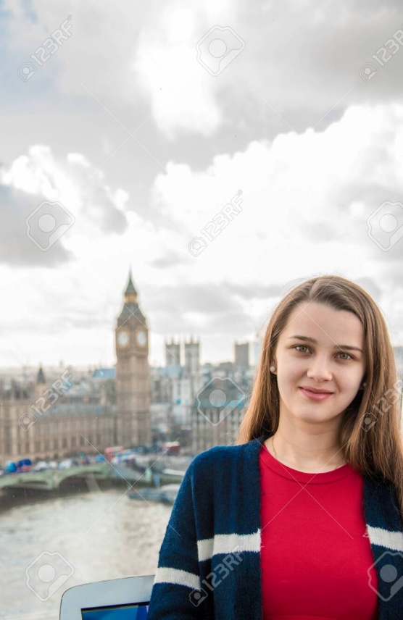
DAY 2: Everyone wakes up much later here. It’s 7:30 am and Fay’s mother is making breakfast. This afternoon, we’re going shopping in Oxford Street, and then we’re going to the cinema. I’m really excited!
DAY 4: Today, I’m going to Fay’s school by tube. It’s a long way from her home so children have to commute. Her school is huge with about 1,500 students. Her friends are very helpful. I’m enjoying the lessons but most of all I love the facilities. There’s a spacious computer room and a lovely school canteen where students have lunch. The sports facilities and the swimming pool are also amazing!
DAY 6: Today, I’m feeling a bit tired. It’s really noisy here and you hear the sound of the traffic all night. I think I’m getting a bit homesick. I miss the beautiful countryside and my friends from my hometown. I’m happy I’m going home tomorrow, but I’m sure I’ll visit London and Fay’s lovely family again!
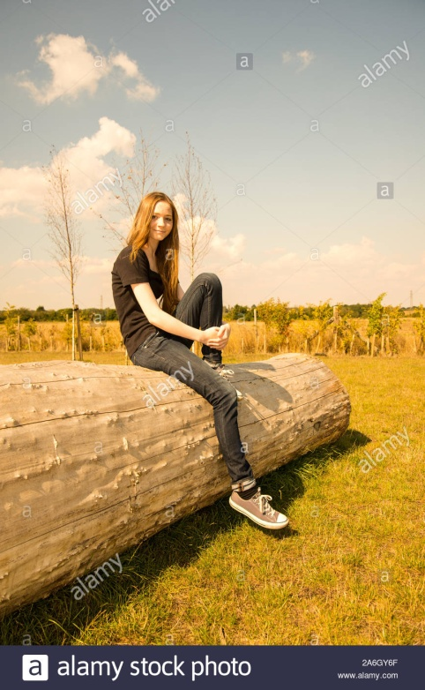
Fay’s Diary
DAY 2: Everyone here gets up at 5 am because there’s a lot to do in the farm. Jill’s mum is really nice. She brings me a cup of tea in bed but then I just go back to sleep! Later, I go outside in the farmyard to help Jill’s family. Today, we’re milking the cows in the barn and feeding the chickens. The animals are lovely but I can’t stand the smell!
DAY 4: Jill’s mum takes me to the bus station every morning. There, I catch the bus that comes at 7:00. Jill’s school is very small but everyone is friendly. All children are friends and get on well with each other. The teachers are friendly and helpful, too.
DAY 6: Learning about farming is interesting but I’m happy I’m going home tomorrow. The fresh air is nice but it’s too quiet here! I also feel isolated. In the city the streets are always crowded but you have everything close at hand. I miss the hustle and bustle of London, but I feel sad because I have to leave my new friends.
- Answer the questions
- Who feels excited? Why?
- What can’t Jill stand?
- What does Jill love at Fay’s school?
- Whose school is small?
- What doesn’t Fay like about farm animals?
- What does Fay miss?
- Who’s getting homesick?

- Explain the words in bold and use them to make sentences.
7

- Complete:
- Jill loves …………………………………………….……………….
- Jill enjoys …………………………………………………………..
- Jill fells excited about …………………………………………
- Jill hates ……………………………………………………………..
- Fay loves ……………………………………………….……………
- Fay enjoys ………………………………………………………….
- Fay likes ……………………………………………………………..
- Fay hates …………………………………………………………...
Now use the phrases and what you remember from the texts to say and write how the girls feel about swapping homes.
- The underlined words in the text are all adjectives showing feelings. Put them in the correct group and add the following ones.
fed up pleased cheerful frightened furious proud
joyful nervous scared upset worried embarrassed
feeling good | feeling bad

- I feel …………………………………..……. when I listen to a melancholic song.
- I feel ………………………………….……. every time I have to take a test.
- I feel ……………………………….………. every time my parents are late.
- I feel ……………………………..……….. when I get high marks.
- I feel ………………………….…………… when I listen to a strange noise at night.
- I feel …………………………..………….. when people don’t talk to me.
- I feel …………………………………………. when the teacher asks me a question and I don’t know the answer.
- I feel …………………………….…………. every time I can meet my friends and spend time together.
- I feel ………………………………………. when my sister breaks my things.
- I feel ………………………….…………….. when there’s a storm outside.
- I feel ……………………………..…………… when schools break up in the summertime.
- I feel ……………………………….……………… every time I do well in class.
- I feel ………………………………………………. when I get a present.
- I feel ………………………………..……………. when I watch a thriller.
Now make up your own sentences. 8
Let’s Practise: COMPARISONS
Positive=θετικός | Comparative=Συγκριτικός | Superlative=Yπερθετικός
clean | cleaner (than) | the cleanest of/in
large | larger (than) | the largest of/in
happy | happier (than) | the happiest of/in
big | bigger (than) | the biggest of/in
comfortable | more comfortable (than) | the most comfortable of/in
good | better (than) | The best of/in
bad | worse (than) | the worst of/in
much/many | more (than) | the most of/in
little | less (than) | the least (of/in)
far | farther/further (than) | the farthest/furthest
ALSO: My room is as big as yours.
Rome is not as crowded as London.

- Make comparisons with the clues.
- noisy – village / city ……………………………………………………………………………………………………………………………….
- heavy – elephant / rabbit ……………………………………………………………………………….…………………………………………
- tall – The Alps/ Mount Everest ………………………………………………………………………………………………………………….
- dangerous - motorbikes / cars ……………………………………………………….…………………………………………………………
- far– Turkey / Japan ………………………………………….……………………………………………………………………………………….
- powerful – bear / fox……………………..…………………………………………………………………………………………………………
- ancient – The Parthenon / The Pyramids ………………………………………………………………………………………………..

- Make comparisons in the superlative form with the animals in the pictures. Use: large, colourful, strong, dangerous, intelligent, small
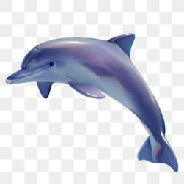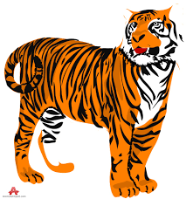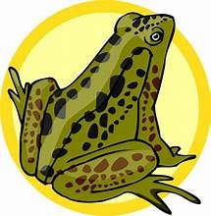
dolphin peacock panda cobra tiger frog
…………………………………………………………………………………………………………………………………………………………………………………………………………………………………………………………………………………………………………………………………………………………………………………………………………………………………………………………………………………………………………………………………………………………………………………………………………………………………………………………………………………………………………………………………………………………………………………………………………………………………………………………………………………………………………………………………………
……………………………………………………………………………………………………………………………………………………………………… 9
3. Use “as ……………………. as” in the blanks:
1. Jack’s English is worse than Sonia’s. Jack’s English isn’t ………………………………………. Sonia’s.
2. Harry’s bag is 3 kg. Bruce’s bag is 5 kg Harry’s bag isn’t …………………………………………….. Bruce’s bag.
3. An orange is sweeter than a lemon. A lemon isn’t ……………………………………………. an orange.
4. Terry is 1.70 cm tall. Jason is 1.70 cm tall too. Terry is ……………………..…………………………… Jason.
5. Chinese is more difficult than French. French isn’t ……………………………………………. Chinese.
6. Adventure films and thrillers are very exciting. Adventure films are …………………………………………. thrillers.
7. Biology is more difficult than Chemistry. Chemistry isn’t ………………………………………………… Biology.
8. July is hotter than May. May isn’t ……………………………………… July

4. Put the following adjectives in 2 groups. Then, use them in the right form to complete the sentences.
● safe ● polluted ● peaceful ● crowded ● big ● stressful ● exciting ● helpful ● relaxing
● busy ● healthy ● noisy ● fast ● expensive ● lonely ● clean ● dangerous ● boring

CITY LIFE: ..........................................................................................................................................................................
...........................................................................................................................................................................................
COUNTRY LIFE: .................................................................................................................................................................
.............................................................................................................................................................................

1. The air in the country is ____________________ but in the city it is ____________________________.
2. City life is ___________________________ because there are plenty of things you can do. This is why living in the country can be ______________________________.
3. Cities are _____________________ than villages and ____________________ because more people live there.
4. People in the city may feel _______________________ because they don’t have time for each other.
5. In the country there is less crime, so people feel ____________. In the city life is ____________________.
6. The cost of living is ____________________ in the city.
7. There is a strong sense of community in the country and neighbours are usually ________________________.
8. There is less pollution in the country and so people have a ______________________ life.
9. It’s quieter and ___________________ in the country. It is ________________ in the city because of the traffic.
10. In the city there is more hustle and bustle, so living there can be _______________________. Life in the country is much ________________________ than in the city.
11. People seem to be ____________________ in the city because they are always working and running around.
12. Life in the city is ______________ - in the country life moves a bit slower.

5. Fill in the blanks with the adjectives in brackets:
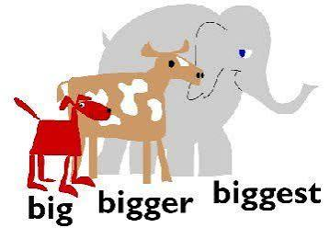
1. Tom is ……………………………………….………………… his brother. (old)
2. This problem is ……………………..…………………………. that problem. (easy)
3. John is ……………………………………..…………………. boy in our class. (tall)
4. My friend is ……………………….………………………. my sister. (young)
5. My room is ………………….………………………… room in our house. (small)
8. Greg is ………………………………………….. boy in class. (popular)
9. My English is ……………………………………….. your English. (good)
10. The weather today is ………………………………………. the weather yesterday. (bad)
11. This garden is …………………………………………….. that garden. (large)
12. Elizabeth is ………………………..…………………………. girl in our group. (beautiful)
13. I am ……………………………………………………… girl in the class. (short)
14. What is ……………………………………………….. film on TV today? (funny)
15. Who is ………………………………..……………… girl in your class? (pretty) 10
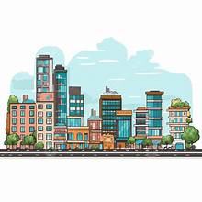
Let’s Read and Write
Hi! My name’s Jenny. I’m 13 years old. I live in a big city in England called Leicester.
I think life in a big city is fantastic. I have always lots of things to do and there are lots of places to visit. I like going to the theatre or cinema and visiting museums. I love pop music and there are usually pop concerts in the city. We usually go to concerts with my friends. I’m crazy about Chinese food, so I often go to a Chinese restaurant with my parents.
One thing I don’t like about the city is the heavy traffic. There are always lots of cars and buses in Leicester because most people have to commute to work and it‘s sometimes difficult to move around in the streets. Also, I can’t stand the noise.
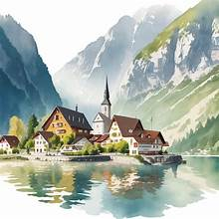
My cousin Daniel lives in a small village near Leicester. Daniel thinks life in the countryside is better than life in the city. There’s no traffic or noise. People can work or walk outdoors. It is calm, silent and peaceful in the countryside. The air is cleaner because there are more trees around and less traffic. There is a beautiful lake and a wonderful forest near Daniel’s village. He usually goes rowing in the lake or hiking in the forest.
Daniel often visits me. We do a lot of things together. We often go to the cinema or swimming in a fantastic indoor swimming pool. I often visit Daniel too. Then we like walking in the forest or swimming in the lake.
1. Where does Jenny live? .................................................................................................................................................
2. Why does she like living in the city? ............................................................................................................................
3. What does she enjoy doing? ..........................................................................................................................................
4. Does she often go to a Chinese restaurant? Why? ........................................................................................................
5. What doesn’t she like about the city? ...........................................................................................................................
6. Why is there such a lot of traffic in Leicester? ...............................................................................................................
7. Where does Daniel live? ................................................................................................................................................
8. What is Daniel’s opinion about living there? ................................................................................................................
9. Why is it so calm and peaceful there? ..........................................................................................................................
10. What does Daniel usually do? .....................................................................................................................................

1. Complete with an adjective or an adverb.
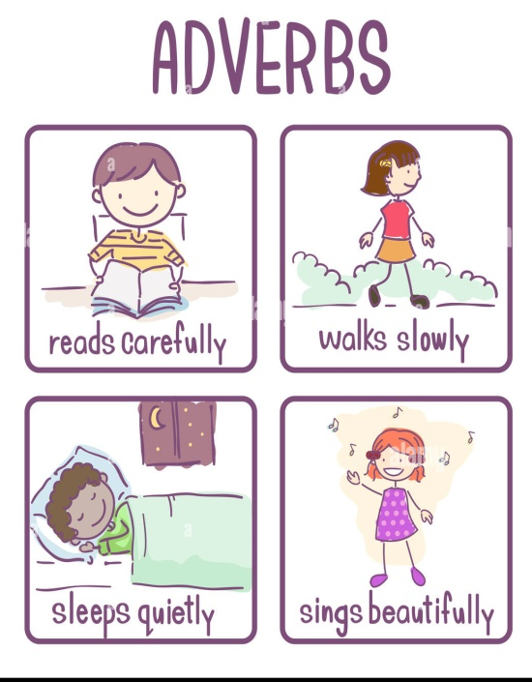
1. He always does his homework ……………………………………….. (careful).
2. He is a very ……………………………………… (careful) student.
3. Come ………………..……………… (quick). We need your help.
4. You should drive more …………………..…………… (slow) along this road.
5. The old man walks very ………….………………….. (slow).
6. Helen is a very ……………………..……………. (slow) student.
7. Her brother, on the other hand, learns …………………..………………… (rapid).
8. Mr. Gonzales has a ………………………………. (permanent) visa.
9. He hopes to remain in this country ………………………….. (permanent).
10. This is an ……………………..……… (easy) exercise.
11. I can do all of these exercises …………….……………… (easy).
12. Helen works very ……………………..…………… (hard) in her new job.
13. You walk very ………………..……………… (fast).
14. They are both ……………………….……………. (serious) students.
15. They both study English very …………………………………… (serious).
16. This apple is very ………………………. (soft).
17. She always speaks ………………………. (soft) to the child.
18. Helen is a ……………………………….. (beautiful) girl.
19. Her sister plays the violin ………………………………… (beautiful) 11

City Life or Country Life?
Read the phrases below. Put each phrase in the correct group in the table:
- City Life (+) Advantages / City Life (-) Disadvantages
- Country Life (+) Advantages / Country Life (-) Disadvantages

1-Fresh air & clean nature
2-Heavy traffic & traffic jams
3-Great places to hang out (cinemas, cafes, malls)
4-Friendly & helpful neighbours
5-Air pollution & trash in the streets
6-Beautiful landscapes & views
7-Fast public transport (buses, metro)
8-Peaceful and quiet
9-More job opportunities
10-So much noise & crowd
11-Cheaper cost of living
12-Modern hospitals & doctors
13-Fun events (concerts, theme parks)
14-Short distances to school or shops

City Life (+) | City Life (-) | Country Life (+) | Country Life (-)
• | • | • | •
• | • | • | •
• | • | • | •
• | • | • | •
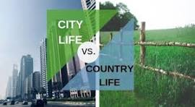
Use the phrases from your table and the linking words to write about Life in the City.
Life in the City
Living in a big city has a lot of pros, but it has some cons, too.
On the one hand, there are many good things. First, ____________________________________________________
_______________________________________________________________________________________________
Next,__________________________________________________________________________________________________________________________________________________________________________________________
Also,__________________________________________________________________________________________________________________________________________________________________________________________
Finally, _________________________________________________________________________________________
_______________________________________________________________________________________________
On the other hand, city life isn't always easy. To begin with, ______________________________________________
_______________________________________________________________________________________________
Second, ________________________________________________________________________________________
_______________________________________________________________________________________________
Also____________________________________________________________________________________________
_______________________________________________________________________________________________
All in all, the city is exciting, but it can sometimes be stressful!

Now, use the exact same paragraph structure to write about Life in the Countryside (about 100 words).

12
UNIT 3: FOOD & COOKING

Let’s Learn: How much do you know about food?
1. Which food is not a dairy product?
a. cheese b. rice c. milk
2. Which is a summer fruit?
a. orange b. fig c. apple
3. What can you make with eggs?
a. an omelet b. soup c. a pie
4. What is a starter?
a. the last dish b. the main dish c. the first dish
5. Which is a leafy vegetable?
a. carrot b. lettuce c. cucumber
6. Which is the healthiest meat to eat?
a. beef b. pork c. chicken
7. Which fruit is used to make wine?
a. grapes b. oranges c. strawberries
8. Which food belongs to pulses?
a. spaghetti b. cereal c. beans
9. Which food belongs to grains?
a. corn b. yoghurt c. honey
10. What is a dessert?
a. the last dish b. the main dish c. the first dish

Correct Answers:
8-10: You’re a food expert! 6-9: You ‘re OK but you must learn a little more! 1-5: Learn what you eat!
2. Write what you see
1 2 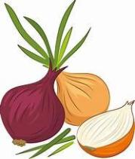3 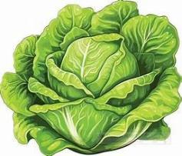4 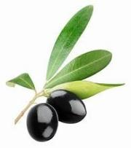5 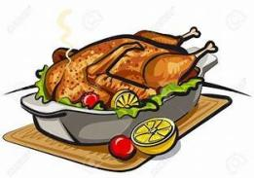6 
7 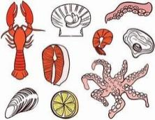8 9 10 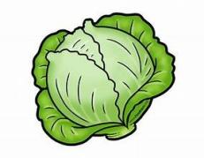11 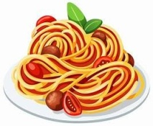12 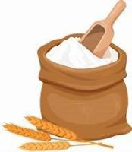
1……………………………………………… 5…………………………………………… 9………………………………………………
2………………………………………………. 6…………………………………………… 10………………………………………………
3………………………………………………. 7…………………………………………… 11……………………………………………
4………………………………………………. 8…………………………………………… 12……………………………………………

Let’s Watch: Do the quiz in the following video.
https://www.youtube.com/watch?v=CT26X6o208g
After the video make a similar “What am I” question and play the game in class.
13
Let’s Read: Food in Britain
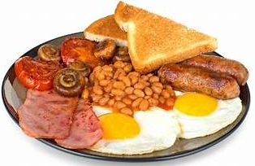
Hi, I’m Jill. I’m 12 and I live in Liverpool with my parents and my younger brother, Jonathan. Do you know what British families eat? Read on to find out.
Friday morning
Breakfast time at home. We usually eat something simple like milk and cereal or toast and jam and run to catch the bus to school. We all love the traditional English breakfast - bacon ,fried eggs, tomatoes, mushrooms , beans ,toasted bread and sausages. And of course tea, orange juice or coffee. It’s very nutritious but on weekdays everyone is in a hurry, so Dad makes it for us on Saturday mornings and we all enjoy it.
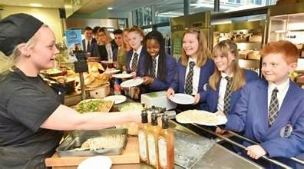
School lunchtime
Do the children in your country eat lunch at school? In Britain we do. Some children bring a packed lunch from home while others prefer a cooked meal in the school canteen.
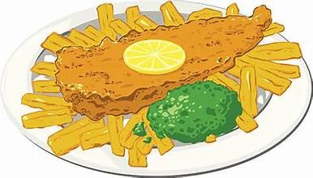
Friday evening
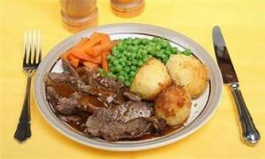
At around 6 o’clock in the evening, most families in Britain sit around the table and enjoy dinner. Dinner is for us the main meal of the day. On weekdays, home-cooked food is usually on the menu but on Fridays we order a takeaway. There is such a huge variety of different cuisines to choose from that it’s always hard for us to decide what to order. Indian, Chinese and Mexican food are the most popular but not as popular as the British favourite fish and chips. This is large fried pieces of cod fish in vinegar sauce and chips. Yummy!
Sunday lunchtime
Sunday means roast beef, lamb or chicken for the British. Today, it’s lamb and I’m helping mum make the dessert. Sunday lunch is a time when we all have the time to enjoy eating home-cooked food together.

A. Answer the questions from the text.
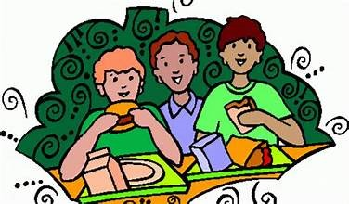
1. What do they have for breakfast on weekdays?
2. Why can’t they have a traditional English breakfast on weekdays?
3. What does a traditional English breakfast include?
4. Do all children eat in school canteens?
5. What is the main meal of the day for the British?
6. What do they eat on Friday evening?
7. Why is it hard to decide what takeaway to order?
8. What is the most popular choice?
9. What do they eat for lunch on Sunday?

B. Answer the questions about food habits in Greece.
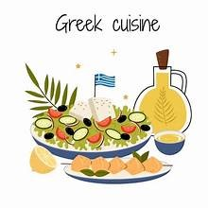
1. What do you usually have for breakfast?
2. Why is breakfast an important meal? Why shouldn’t we skip it?
3. Do you take a packed lunch at school or do you buy a snack? What do you usually eat?
4. Which is the main meal of the day in Greece?
5. What is your favourite home-cooked meal?
6. How often do you order a takeaway?
7. Which is your favourite takeaway?
8. What do you usually have for Sunday lunch?
9. What is your favourite dessert?
10. Do you like any foreign cuisine?

C. Write a paragraph with the title “Food in Greece”. Use the questions in Task B to help you.

14

Let’s practise: Countable & Uncountable Nouns
A. Mark C for Countables and U for Uncountables.
1.milk _____ 2.cucumber _____ 3.potato _____ 4.cherry _____ 5.olives _____ 6.yoghurt _____ 7.carrot _____ 8.peach ____ 9.money ____ 10.water ____ 11.egg ____ 12.flour ____ 13.time ____ 14.oil ____ 15.sugar ____ 16.onion _____ 17.banana _____ 18.bread _____ 19.cheese _____ 20.lemonade _____ 21.hamburger _____ 22.orange _____ 23.coffee _____ 24.salt _____ 25.rice _____ 26.beer _____ 27.chicken _____ 28.tea _____ 29.book _____ 30.love _____ 31.meat _____ 32.fork _____ 33.knife _____ 34.butter ____ 35.spoon ______

B. Fill in the blanks with a / an / some / any
1. There is _________ honey in the jar. 9. There are ________ strawberries in the bowl.
2. There aren't ________ apples in the basket. 10. Do you want to eat __________ orange?
3. There is _________ egg on my plate. 11. There is __________ tomato in the basket.
4. There isn't _________ water in the glass. 12. There is __________ jam in the big jar.
5. There is __________ chicken and salad. 13. We don't need ___________ bread today.
6. Let's buy __________ cheese from here. 14. I need ___________ lemon for the salad.
7. There is __________ pizza in the box. 15. There are __________ carrots in the fridge.
8. There isn't _________ milk in the bottle. 16. Susan has got _________ apple. It's juicy.

C. Fill in some or any as in the example
1. Are there …….. any ………… rabbits in the garden? 8. Are there ……………………… fish in the water.
2. Are there …………………… children in the class? 9. Are there …………………….. oranges in the basket?
3. There aren’t ………………….. chairs in the room. 10. There isn’t ……………………. milk in the fridge.
4. Are there ……………………… birds in the tree? 11. I have …………… tea, but I don’t have ……………… sugar.
5. There isn’t ……………………. money in the bag. 12. Is there ………………… meat at home?
6. There is ………………………. coffee in the cup. 13. There were ………………… apples here a minute ago.
7. There are …………………….. policemen in the police station. 14. There aren’t ……………….. glasses on the table.

D. Write how much or how many
1. ____________ cans of coke do you want? 11. ____________ kilos of meat does she want to buy?
2. ____________ orange juice is there in your glass? 12. ____________ sugar would you like for your tea?
3. ____________ time have we got to go to school? 13. _____________ bananas are there in that basket?
4. ____________ olive oil do you need for your cake? 14. ____________ jam is there in that big jar?
5. ____________ money do you earn? 15. ___________ lemonade will you make for the party?
6. ____________ people are there in your class? 16. ___________ cars does that rich man have?
7. ____________ pencils would you like to buy? 17. ____________ hours does Steven sleep every night?
8. ____________ computers are there in your house? 18. ____________ bars of chocolate would you like?
9. ____________ hamburgers do you eat a week? 19. ____________ children are playing in the garden now?
10. ___________ bread do you eat at breakfast? 20. ____________ sleep does an adult need a day?
21. ____________ salt do you put in your soup? 22. ____________ t-shirts does she have in her wardrobe?

E. Fill in how much, how many, a few, a little, some or any
1. A: ……………………………. bananas would you like, sir? 6. A: ……………………. sugar would you like in your coffee?
B: Just …………………………. , please. B: Just ………………………, please.

2. A: Can I have …………………………… milk? 7. A: Could I have ……………………. tea, please?
B: Sorry, we haven’t got ……………………….. milk. B: Would you like ………………………. biscuits, too?
15
3. A: ………………………… bread would you like? 8. A: Is there ………………………. wine in the fridge?
B: Just ……………………….. , please. B: No, we need to buy …………………….

4. A: ……………………… carrots do we have? 9. A: ………………………. flour does Mom need?
B: We have only …………………………. . . B: Just ……………………..

5. A: ……………………….. oranges do we need? 10. A: Have you got ……………………… potatoes?
B: We don’t need ……………………….. oranges. B: Yes. …………………………. would you like?

F. Fill in some, any, much or many:
1. A: I’d like ……………………. eggs, please. 2. A: I’d like …………………… olive oil.
B: Of course. How ……………………. would you like? B: How ……………………… do you need?
A: Six, please. Are there ……………………… tomatoes? A: Half a bottle. Is there ……………………. flour?
B: Certainly. How …………………… do you need? B: Certainly. How ………………………. do you need?
A: A kilo, please. A: Half a kilo, please.

TURNING UNCOUNTABLES INTO COUNTABLES.
F. Write what you see in the pictures.
1 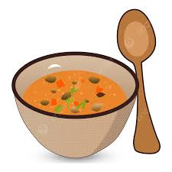 2 3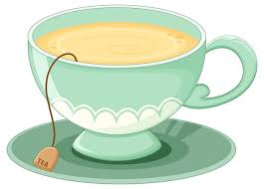 4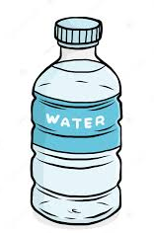 5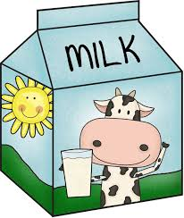 6

7  8  9  10 11

1213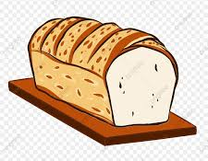14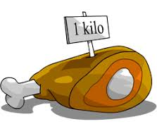 15  16 

- ….a bowl of soup……………………….. 9. …………………………….……………………..
- ………………………………………….………. 10. …………………………………………………..
- ………………………………………………….. 11. …………………………………………………..
- ………………………………………………….. 12. ……………………………………………………
- ………………………………………………….. 13 …………………………………………………….
- ………………………………………………….. 14. ……………………………………………………
- ………………………………………………….. 15 …………………………………………………….
- ………………………………………………….. 16 …………………………………..…………………

16
Let’s Learn: Cooking is fun
Everyone knows that home-made food is tasty and nutritious. But do you know that making it can be fun?
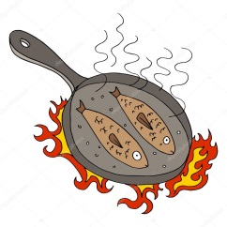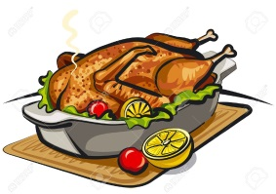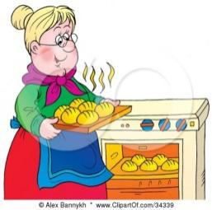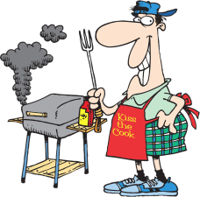
boil fry roast bake grill
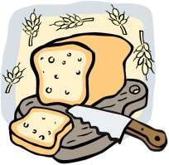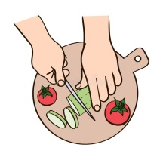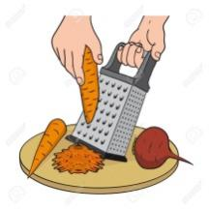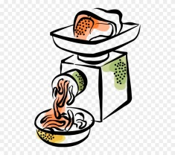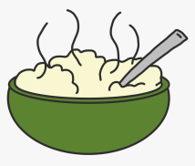
peel slice chop grate mince mash
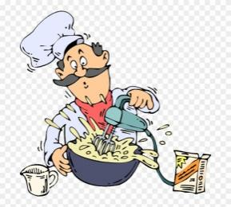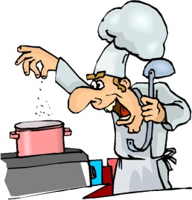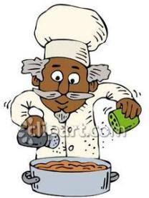
mix stir add sprinkle serve
Say and Write:
- Write 5 things you can boil: …………………………………………………………………………………………………………………
- Write 5 things you can fry: …………………………………………………………………………………………………………………..
- Write 5 things you can roast: ………………………………………………………………………………………………………………
- Write 3 things you can bake: ………………………………………………………………………………………………………………
- Write 4 things you can grill: ………………………………………………………………………………………………………………...
- Write 3 things you can peel: ………………………………………………………………………………………………………………..
- Write 3 things you can slice: ………………………………………………………………………………………………………………
- Write 5 things you can chop: ………………………………………………………………………………………………………………
- Write 3 things you can grate: ………………………………………………………………………………………………………………
- Write 2 things you can mince: ………………………………………………………………………………………………………………
- Write 2 things you can mash: ………………………………………………………………………………………………………………
- Write 4 things you can sprinkle food with: ………………………………………………………………………………………….
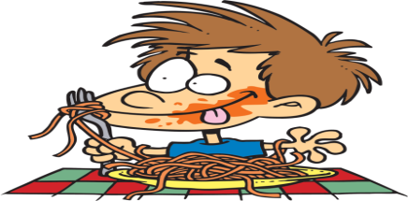
- Write 5 green vegetables …………………………………………………………………………………………………………………….
- Write 6 summer fruit ………………………………………………………………………………………………………………………….
- Write 4 dairy products ………………………………………………………………………………………………………………………..
- Write 3 kinds of meat ………………………………………………………………………………………………………………………….
- Write 2 kinds of fish ……………………………………………………………………………………………………………………………
17
Let’s write: A recipe

Fill in the recipes with the correct cooking verb

Easy Crispy Potato Bites
fry sprinkle add peel mix chop

Ingredients:
- 3 large potatoes
- 2 tablespoons of olive oil
- 1 pinch of salt and pepper
- 50g of grated cheese
Steps:
1- First, ________________ the potatoes carefully to remove the skins.
2-Next, ________________ the potatoes into small, equal cubes.
3-Put the potato cubes into a big bowl and ________________ the olive oil, salt, and pepper.
4-Use a big spoon to ________________ everything together so the potatoes are well coated.
5-Heat a skillet on the stove and ________________ the potato cubes in a little oil for 10-12 minutes until they are golden and crispy.
6-Serve the warm potatoes on a plate and ________________ the grated cheese on top before eating. Enjoy!

Cheesy Garlic Potato Salad
roast serve grate stir mash slice
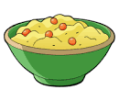
Ingredients:
- 4 medium potatoes (boiled)
- 2 cloves of garlic
- 100g of cheddar cheese
- 2 tablespoons of butter
- Fresh herbs (parsley or chives)
Steps:
1-First, ________________ the garlic thinly into small, flat pieces.
2-Place the garlic in the oven and ________________ it for 10 minutes until it turns soft and sweet.
3-Put the warm boiled potatoes into a bowl and ________________ them with a fork until smooth.
4-Next, ________________ the cheddar cheese into fine shreds over the bowl.
5-Add the butter and roasted garlic, then ________________ the mixture gently until everything is combined and creamy.
6-Put the mash into bowls and ________________ immediately with a garnish of fresh herbs on top. Bon Appétit!

Easy Apple & Chocolate Cake
bake chop grate mix add sprinkle
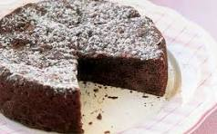
Ingredients:
- 200g flour & 150g sugar
- 2 eggs & 100g butter
- 1 sweet red apple
- 50g dark chocolate
- 1 tablespoon powdered sugar
Steps:
1-First, ________________ the dark chocolate into tiny pieces on a cutting board.
2-Next, ________________ the fresh apple using a hand tool to make fine, juicy shreds.
3-Put the flour, sugar, butter, and eggs into a large bowl, then ________________ the chopped chocolate and grated apple.
4-Use a wooden spoon to ________________ all the ingredients together into a smooth batter.
5-Pour the batter into a cake pan and ________________ it in the oven at 180°C for 35 minutes.
6-Let the cake cool down, then ______________ powdered sugar over the top before slicing. Enjoy your sweet treat!

Now, write your own recipe!
18
UNIT 4: TRAVEL & TRANSPORT
Let’s Read: Means of Transport
Airplane

Airplanes are one of the fastest and most exciting ways to travel long distances. Before your trip, you need to go to the airport, check in your luggage, and get your boarding pass. It is thrilling when the pilot starts the engine and the airplane begins to take off on the runway. It’s fantastic to travel by air because you fly high above the clouds and look down at the world through small cabin windows. Don’t forget to book your flight in advance because air tickets can be quite expensive, especially during holiday seasons.
Train
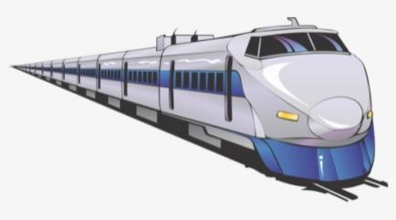
It’s wonderful to travel by rail because trains are very comfortable and spacious. When you arrive at the railway station, you wait on the platform until your train comes along. Inside the carriages, you can sit comfortably, read a book, or walk around. You can see lots of different places because you travel through busy cities, small towns, and peaceful countryside. You can enjoy watching rivers, mountains, and fields through the window and chat with other passengers. Some long-distance trains even have a dining car where you can buy snacks during your journey.
Car
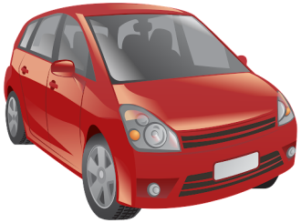
Cars are a popular form of personal transport because they offer a lot of freedom. When you travel in your own car, you can plan your route and choose your own schedule. You can set off, make a stop at a café, or arrive at your destination anytime you like. You can also pack your bags easily in the trunk. Everyone must put on their seatbelt before the driver turns the key. Traveling by car is comfortable for passengers, but long drives on busy roads or highways can be quite tiring for the driver, especially in heavy traffic.
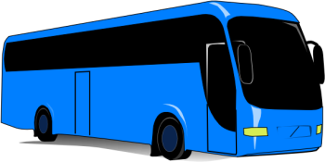
Bus
It’s easy and cheap to travel by bus, making it a very common type of public transport. You can catch a bus at a local bus stop or at a large central bus station. Buses usually follow fixed routes , connecting almost all towns and cities. The main problem with buses is that the journey can be quite slow, which can make long trips feel boring.
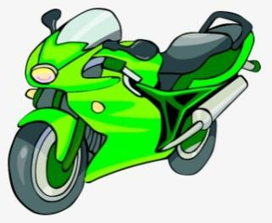
Motorbike
It’s adventurous and fast to travel by motorbike. A motorbike has two wheels and a powerful engine, allowing the rider to move quickly through city streets and navigate around slow cars. However, because motorbikes offer no outer protection, riders must always wear a helmet and protective safety gear. Motorbikes are fun to ride in sunny weather, but they can be uncomfortable in the rain and very dangerous if an accident happens on the road.

Ship
Ships are large vessels designed to sail across deep oceans, seas, and rivers. Traveling by ship or taking a ferry is enjoyable and relaxing, especially when the weather is warm and sunny. Passengers can walk around on the open deck, enjoy the sea breeze, look out at the waves, or sleep in comfortable cabins. Ships dock at a port or harbour to let people on and off. However, when it’s stormy, people can feel seasick.

A.Read the 10 statements below. Match each statement to the correct means of transport (A–F).
- [ ______________ ] You need to go to a railway station platform to wait for this vehicle.
- [ ______________ ] You must always wear a protective helmet when you travel on this.
- [ ______________ ] Rough weather and big waves can make people feel sick on this vehicle. 19
- [ ______________ ] You can plan your own route and put your luggage in the trunk.
- [ _______________ ] It follows a fixed timetable and links many locations along its route.
- [ _______________ ] You go to an airport and check in your luggage before taking off.
- [ _______________ ] Driving this on long highways or in heavy traffic can be very tiring for the driver.
- [_________________ ] Passengers can walk out on the open deck to feel the sea breeze.
- [ _________________ ] You can sit in spacious carriages, walk around, and even visit a dining car.
- [ __________________ ] It has two wheels and a powerful engine to move quickly through city streets.
B.Complete the sentences using the correct bolded word or phrase from the text.
- Always wear a safety _______________________ on your head when you ride a motorbike.
- We packed all our clothes into two large bags of ________________________.
- Make sure to fasten your ___________________________ as soon as you sit down in a car.
- The ship started moving, so we walked outside onto the _____________________ to look at the sea.
- Hundreds of _________________________ were waiting on the platform for the morning train.
- We need to ________________________ early in the morning so we can avoid the morning cars.
- The airplane had to wait on the runway before it could finally ____________________________.
- I prefer to __________________________ train because I like looking at the countryside.
- There was so much heavy _______________________ on the highway that all the cars stopped moving.
- If the ocean waves are too big, some people feel _________________________ and need to lie down.
- After a long three-hour drive, we finally arrived at our _______________________: the hotel.
- I need to leave now because I want to ___________________________ at 8:00 AM at the bus stop.
- Learning to ____________________________ a motorbike takes practice and good balance.
- It was a long _________________________ across the country, but we played games to pass the time.



Let’s Write: My Ideal Journey
Imagine you are planning a dream trip anywhere in the world! Write a short paragraph (50-60 words) about your journey.
- Choose a means of transport for your trip.
- Use at least 4 words from your new vocabulary list
- Underline the target vocabulary words you use.
Follow the example:
For my summer vacation, I want to visit London. My family will set off early in the morning to go to the airport with all our luggage. When our plane is ready to take off, I will fasten my seatbelt and enjoy the view. When we arrive at our destination, we will catch a bus to the city center. I think it will be a fantastic journey!
20
Let’s Learn: Going on holidays

1. When you are on holidays, where do you like staying at?
a. a five-star hotel b. a campsite c. a cosy hotel
2. What do you enjoy visiting?
a. monuments b. art galleries c. churches
3. Museums? Well, I think they’re. …
a. fantastic b. boring c. interesting
4. What do love doing on holidays?
a. taking sightseeing tours b. going shopping c. taking boat tours
5. Where do you enjoy going shopping?
a. in flea markets b. in local shops c. in shopping malls
6. Which famous landmark would you like to visit?
a. Big Ben b. the Eiffel Tower c. the Statue of Liberty
7. What do you prefer buying?
a. souvenirs b. local handicrafts c. local products
8. What type of holiday do you like?
a. city breaks b. camping c. cruise
9. What do you prefer seeing?
a. buildings b. statues c. parks
10. What do you like eating?
a. local cuisine b. fast food c. unusual food
- Write the words for the pictures
1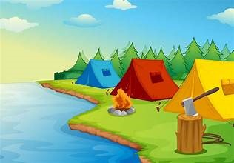 2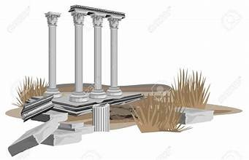 3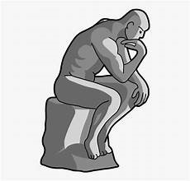 4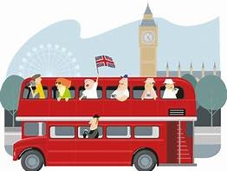
………………………………………….. …………………………………………. …………………………….. ……………………………………………
5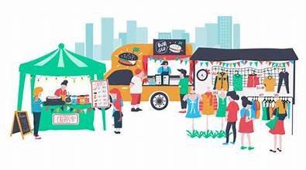 6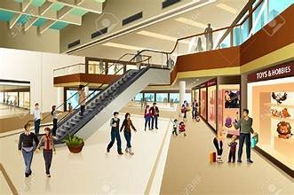 7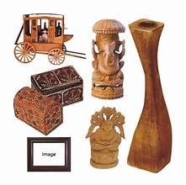 8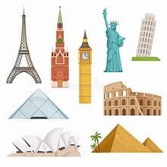
……………………………….. …………………………… …………………… …………………….
- Complete the sentences using the correct phrase or word from the box.
cosy hotel monuments sightseeing flea markets souvenirs cruise statues local cuisine
1)During our city tour, we went ____________________ to see all the famous buildings and places.
2)We stayed in a very ____________________ with small, warm rooms and friendly staff.
3)Before going home, I bought some small ____________________, like keychains and postcards, for my friends.
4)We took a evening ____________________ along the river to see the city lights from the water.
5)In the square, there were big stone ____________________ of famous kings and queens.
6)If you love old or second-hand items, you should explore the local ____________________ on Sunday morning.
7)Trying the ____________________ is my favorite part of traveling; I loved the local soups and freshly baked bread!
8)The city is full of historic ____________________ that tell stories from hundreds of years ago.
- Answer these quick questions using the new vocabulary!
- Name one souvenir you always like to buy when you visit a new place: ____________________________
- Name one famous statue and one landmark you know from anywhere in the world: ___________________
21
Let’s Practise: Past Simple

A) Write questions and answers. Use the past tense of BE:
1. A: We had a nice holiday.
B: (you / with your whole family?) …….. Were you with your whole family?……………………………………………
A: (no / my daughter / in Montreal) …….. No, my daughter was in Montreal…………………………………………...
2. A: I bought these new shoes yesterday.
B: (they / on sale ?) ………………………………………………………………………………………..….…………..
A: (yes / they / only $25) ………………………………………………………………………………………………………...
3. A: (you / at home / last night ?) ……………………………………………………………………………..…………………………..
B: (no / I / at the library) …………………………………………………………………..……………………………………..
4. A: (the guests / late for the party ?) …………………………………………………………………..…………………………………….
B: (no / they / all on time) …………………………………………………………… …………………………………………….

B) Fill in with the Past Simple.
- The children __ played__ (play) hide and seek an hour ago.
- I ____________ (relax) on the beach with my friend last Saturday.
- The Coopers _____________ (paint) their house yesterday.
- Alice ___________ (help) her mum with the shopping bags.
- Martin ___________ (ask) the teacher a question.
- It ____________ (snow) a lot on Christmas day.
- The train ___________ (arrive) at the station at 3:45 pm.
- My brother ____________ (want) us to watch cartoons, but I _________ (prefer) a comedy.
- The lifeguard _____________ (save) the drowning lady.
- The team ______________ (plan) to win by following the coach’s instructions.
- Jill ____________ (tidy) her room the day before yesterday.
- Tom ____________ (watch) an interesting movie last night.
- Celia ____________ (study) history when she was twenty years old.
- Paula _______________ (tidy) her room last week.
- Our neighbour _________________ (shout) for help yesterday.
- Andy ______________ (like) his new jacket.
- Sam _______________ (finish) his homework an hour ago.
- The girls _______________ (reach) the airport at 2:00.
C) Fill in the blanks with a verb from the box in the SIMPLE PAST:
break swim have make sit write spend buy drink lose wash
1. She ………………….. a cake an hour ago.
2. She ………………….. a hat last week.
3. The boy ………………….. a letter yesterday.
4. They ……………………. in the sea for an hour.
5. They ………………….. a lot of Coke last night.
6. She ………………… her arm last week.
7. He ……………………. all his money last week.
8. She …………………… a bath two minutes ago.
9. He ……………………. his wallet last night.
10. She ………………….. on the old chair a minute ago.
11. She ………………….. the clothes yesterday.
D) Write what Jean DID or DIDN’T do yesterday:
go shopping ( - ) ………… Jean didn’t go shopping yesterday. …………….
clean the house ( + ) ………………………………………………………………………..……… 22
feed the cat ( + ) .…………………………………………………………….…………………
telephone Mary ( - ) …………………………………………………………………………………
watch a film on TV ( - ) ………………………………………………………………………………… visit her grandparents ( + ) …………………………………………………….………………………
take them a cake ( + ) …………………………………………..…………………………..……

E)What’s the question?
how what where how long what time who how many how much when why

1. ……………..Who did you visit …………………………………….? I visited my cousin.
2. ……………………………………………………………………….……….? We talked about my job.
3. ………………………………………………………………….…………….? She went to the beach.
4. …………………………………………………………….………………….? Sally met her friend.
5. ……………………………………………………………………………..….? They spoke Italian.
6. ………………………………………………………………………………….? They swam in the ocean.
7. ……………………………………………………………………………..….? John had dinner at 8:00.
8. ……………………………………………………………………………..….? Mum baked an apple pie.
9. ………………………………………………………………………..……….? She cried because her dog ran away.
10. ……………………………………………………………………………….? I stayed in London for a week.
11. ……………………………………………………………………..……….? Paul came home by train.
12. …………………………………………………………………..………….? Tom ate three hamburgers.
13. ……………………………………………………………………………...? He left the restaurant at 9:00.
14. …………………………………………………………………………..….? She wrote a letter to her mother.
15. …………………………………………………………………………..….? They studied all morning.
16. ……………………………………………………………………………….? We took a lot of photographs.
17. ……………………………………………………………………………….? We sent a postcard to our teacher.
18. ………………………………………………………………..…………….? Dad paid 40€ for the tickets.
19. ………………………………………………………………………….….? I lost my wallet when I went sightseeing.
20. …………………………………………………………….……………….? The children covered their eyes because they were scared.
E) Complete the sentences with the verb in the correct tense. Use SIMPLE PRESENT, PRESENT CONTINUOUS, or SIMPLE PAST.
1. I ……………………………….…..(go / not) to the cinema last night. I ……………………..…………. (stay) home.
2. Fred ……………………..…….……. (come / not) to class every day.
3. Sue …………………….………….…… (read) a book right now. She …………………………………….. (watch / not) TV.
4. I ……………………………….……… (finish / not) my homework last night. I ……………………………….………. (go) to bed early.
5. Jane ……………………………………... (stand / not) up right now. She ………………………………………….…. (sit) down.
6. It ……………………………..……. (rain / not) right now. The rain ………………………………………… (stop) a few minutes ago.
7. The weather …………………………….………… (be / not) cold today, but it ………………………………… (be) cold yesterday.
8. Mary and I …………………….…………. (go / not) shopping yesterday. We …………………..……. (go) shopping last Monday.
9. I ………………………………………….. (go) to a movie last night, but I ……………………………………………… (enjoy/ not) it.
10. I …………………………….……………. (write) a letter to my friend yesterday, but I ……………………………………. (write / not) a letter to her last week.
11. Keith …………………..…………………………. (come / not) home for dinner last night. He ………….……………………… (stay) at his office.
12. The children …………………………….…….. (go) to bed a half an hour ago. They ………………………………………. (sleep) now.
13. We …………………………………….……… (be) late for the movie last night. The movie ……………………………….…. (start) at 7:00, but we ………………………………………..….. (arrive / not) until 7:15.
14. She usually …………………………….………. (take) the bus to school but today we ……………………………………. (go) on foot.
23

Let’s Read: A trip to London
Read the email from Emma to her friend. Fill in with the correct Simple Past form. Then answer the questions.
Hi Sarah,
How are you? I am having an amazing time here! Two days ago, my family and I (fly) _____________ to London. Our journey by airplane (be) _____________ really exciting. We (set off) ____________ to the airport early in the morning with all our luggage. When the plane (take off) ____________ on the runway, I (feel) ____________ so happy! The passengers (look) ____________ out the window at the clouds, and the pilots (land) ____________ the plane very smoothly.
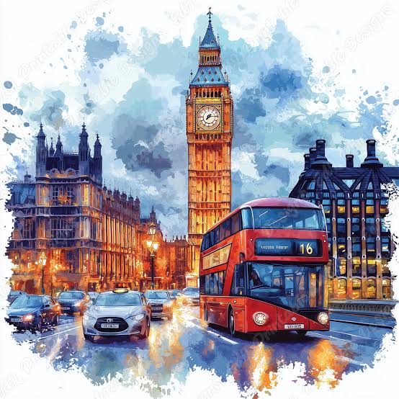
On our first day, we (arrive) ____________ at our hotel in the city center. The room (be) ____________ small, but very comfortable. After we (unpack) ______________ our bags, we (start) ________________ exploring! First, we (walk) _______________ to see Big Ben. It (look) _______________ huge in real life! Then, we (take) ____________ a double-decker bus to Buckingham Palace to see where the King lives. In the evening, we (eat) _________________ traditional fish and chips for dinner at a local restaurant. It (taste) ___________________ delicious!
On the second day, we (have) ____________ a big traditional English breakfast with eggs, sausages, and beans at the hotel. After that, we (catch) __________________a bus to the Tower of London to see the historic castle. Next, we (ride) _____________ the famous London Eye! The view from the top (be) ____________ fantastic. In the afternoon, we (go) ____________ shopping at Harrods and (buy) _________________ some nice souvenirs. Finally, in the evening, we (watch) ____________ a fantastic musical at a theater in the West End.
We are packing our bags now to go back home by train. I can't wait to tell you all about my trip! See you soon!
Love,
Emma
Read the email from Emma and answer the questions.

Paragraph 1: The Journey by Plane ✈
1) How did Emma feel when the airplane took off? ……………………………………………………………..………………………………..
2)What did the passengers do during the flight? …………………………………………………………………………………………………..
3) Why does Emma start her email with the journey?
  - [ ] To explain how she got to London before talking about the sights.
  - [ ] To list all the things she bought.

Paragraph 2: Day 1 in London
1)Which two famous places did Emma's family visit on their first day? ………………………………………………………………….
2)What did they eat for dinner on the first evening? ……………………………………………………………………………………………..
3) What key details does Emma include about her first day?
Where they stayed The places they visited What they ate for dinner How much money they spent

Paragraph 3: Day 2 in London
1) What food did Emma eat for breakfast on the second day? ……………………………………………………………………………..
2)Where did they go shopping in the afternoon? …………………………………………………………………………………………………
3) What activity did they do in the evening at the West End? ……………………………………………………………………………..
4) Notice the time words Emma uses in Par. 3 (e.g., After that, Next, In the afternoon, Finally). How do these words help the reader?
  - [ ] They make the email look longer.
  - [ ] They help show the order of events throughout the day.

Paragraph 4: Closing
5) How is Emma going back home? 24
6) How does Emma finish her email?
  - [ ] She talks about her homework.
  - [ ] She says what she is doing right now and adds a friendly closing line ("See you soon!").

Let’s write: A trip to Athens
Now write a similar e-mail to a friend describing a weekend trip to Athens. First write captions for the pictures and then use your ideas and the writing box to write the mail.
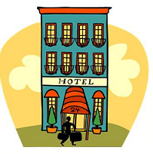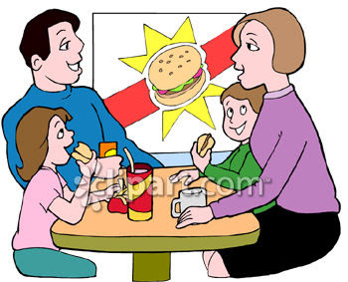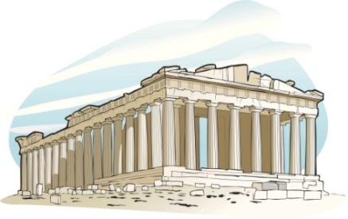
……………………………………………………. ……………………………………………………. …………………………………………………………….
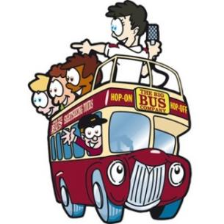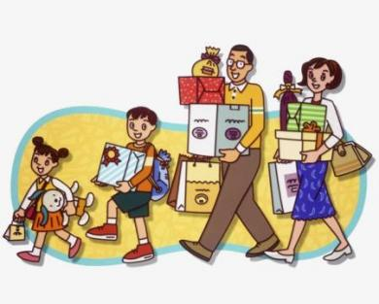
……………………………………………….. ………………………………………………… ………………………………………………………..
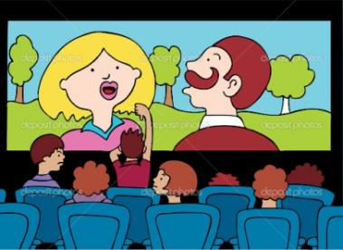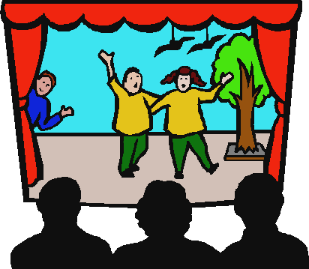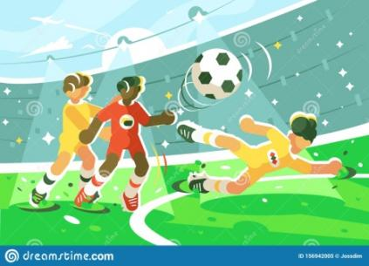
…………………………………………………… …………………………………………………….. ………………………………………………….
Email Part | What to write: | Useful phrases:
Greeting | Say hello to your friend. | Hi... / Dear... / How are you?
Paragraph 1: The Journey | - Say where you went and how you traveled. Who did you go with? How did you go? How was the journey? | Two days ago, I traveled by... / The journey was...
Paragraph 2: Day 1 | Describe your hotel, sight-seeing, and food. | First, we visited... / In the evening, we ate...
Paragraph 3: Day 2 | List your activities in order using time words. | After breakfast... / Next, we went to... / Finally...
Closing | Say what you are doing now and goodbye. | I can't wait to see you! / Love, [Your Name]
25
Let’s Read & Write: A camping holiday
A. Read Chris’s letter about his camping weekend and put the verbs in the Simple Past.
Hi,
I’m back from a fantastic weekend and I’m writing to tell you all about it.
My three friends and I ………….......................…… (decide) to go camping in a mountain. On Friday night, I ……............………… (pack) my rucksack. I …….........…… (put) a pair of hiking boots, a cap and an anorak. I …….....................………… (not/ forget) my sleeping bag and my binoculars because I like birdwatching.
On Saturday morning, we ......................... (take) the bus to the mountain. We …….……...........… (arrive) in the afternoon and …….............…….... (go) straight to the local shop to buy some food. Pete is a good cook and he ……….................…… (bring) a stove and a lighter to cook for us.
When we ………..…...…… (get) at the campsite, we …….........…… (put) the tent up. At night, we ….......…......…....…… (make) a campfire and ………................……… (sit) around. We ………............……… (tell) stories and jokes. The stars in the sky ………..........… (be) wonderful but it was dark, so we ……….........… (use) Tom’s torch to get into our tent.
Next morning, we ……….........… (get) up early and ………...........… (have) a big breakfast. Then we ……........…..…… (go) hiking. We ……….....…… (see) some nice birds, but we ..……...............…… (need) some insect repellent because there ……….....…… (be) lots of mosquitoes near the river. We ……..........…… (fill) our water bottles with fresh water, so we didn’t get thirsty. We also …….........…...............… (find) some mushrooms, but we ………..............…… (not/ pick) them up because we …….…................…… (not/have) a penknife.
We stayed one more night. We all loved camping, so we’re planning to go again soon.
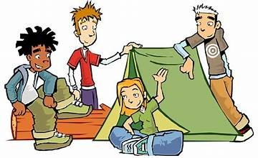
You can join us if you like.
Love, Chris
adapted from islcolloective.com

B: Answer the questions.
1. What did Chris put in his rucksack?
2. How did they go to the mountains?
3. What did they do when they arrived at the campsite?
4. What did they do at night?
5. Why did they use Tom’s torch?
6. What did they do after breakfast?
7. Why did they need some insect repellent?
8. Did they pick up any mushrooms? Why (not)
9. Did they like the camping weekend?
26

C1: Write the highlighted words under the correct picture.
1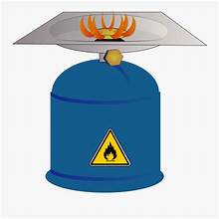2 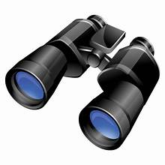3 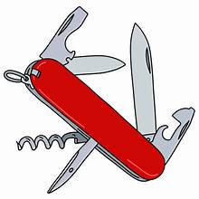4 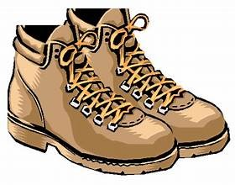5 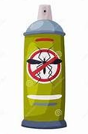6 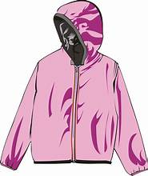

……………………………… ………………………….…….. ……..………………….. ………….…………………. ………………….… ………….………..
7 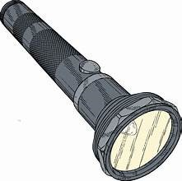 8  9 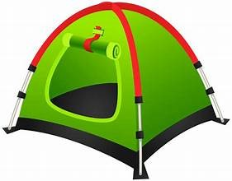 10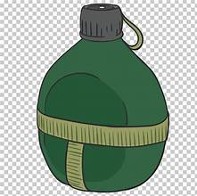 11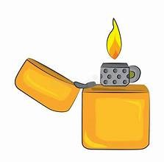 12 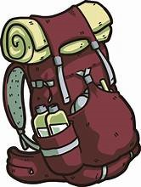
…………….............. ………………………… ………………….. …………………………. ……………..……. ………………….……..

C2: Complete with the missing letters.
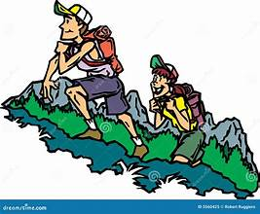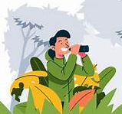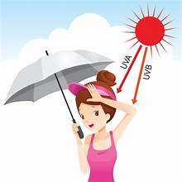
go h _ _ _ _ _ do bird _ _ _ _ _ _ _ _ see in the d _ _ _ protect from the s _ _
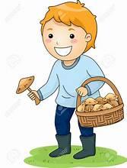 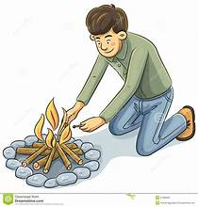 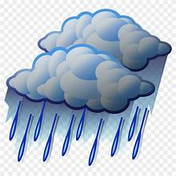 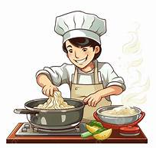 p_ _ _ up mushrooms make a c _ _ _ _ _ _ _ it r_ _ _ _ c _ _ _
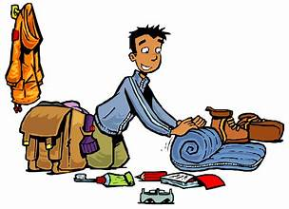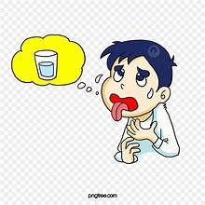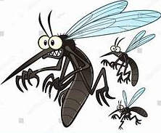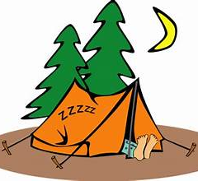
p _ _ _ your things get t _ _ _ _ _ _ protect from m _ _ _ _ _ _ _ _ _ s _ _ _ _ in

27
D: Look at the pictures and make sentences as in the example. Use the phrases in order to or in case.

What do you need to go camping?
 You need a stove in order to cook.
 You need binoculars in case you want to do birdwatching.
……………………………………………………..……………………….………….
…………………………………..……………………………………………
……………………………………………………………………………………….
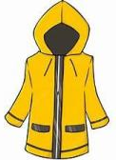 ………………………………..……………………………………………………
……………………………………..………………………………………………..
……………………………………………..……………………………………………………………………………………..
……………………………………………………………………………………………………..…………………………….
…………………………………………………………………………………………………………………………….…………….
………………………………………………………………………………………………………………………………………….
…………………………………………………………………………………………………………………………… 28

UNIT 5: GET THE JOB DONE!

- Write the job under the picture
1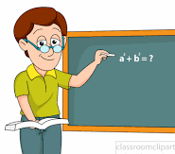 2 3 4  5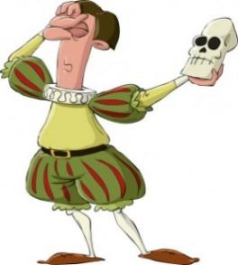
6 ……………………………………………………………………………………………………………………………………..
6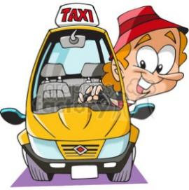 7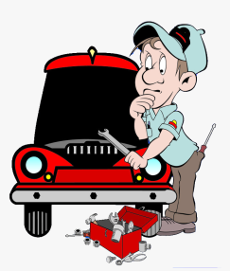 8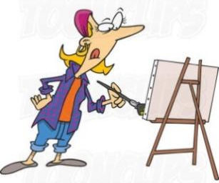 9 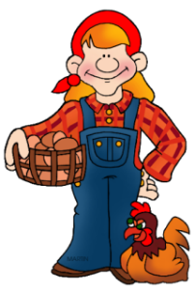 10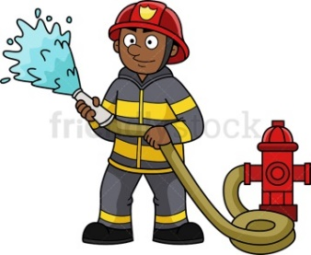
………………………………………………………………………………………………………………………………………………………………………………………..
- Match the qualities with the jobs and make sentences as in the example
a. kind (work with kids or teens) ….Teachers should be kind because they work with kids or teens…………………..……
b. hard working (crops and animals need care) ……………………………………………………………………………………………………………
c. talented (bring characters to life) ………………………………………………………………………………………….…………………………………
d. brave (put out fires) …………………………………………………………………………………………………………………………………………………
e. patient (drive for hours in traffic) …………………………………………………………………………………………………………………………..
f. skilled (fix machines) ……………………………………………………………………………………………………………………………………………….
g. strong (cleaning is tiring) ………………………………………………………………………………………………………………………………………….
h. imaginative (make up pictures) ……………………………………………………………………………………………………………………………..
i. creative (make new recipes) ……………………………………………………………………………………………………………………………………..
j. responsible (work with sick people) ………………………………………………………………………………………………………………………..

- Think of two more jobs and write what qualities people who do them should have.
..............................................................................................................................................................................................................................................................................................................................................................................
29
Let’s Practise: The Present Perfect Tense

Have you ever …? - Present Perfect for Experiences -
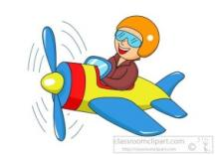 1 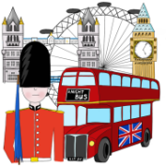 2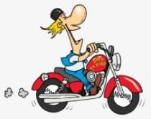 3 4 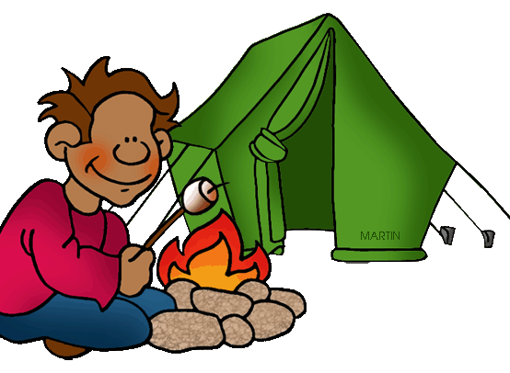56 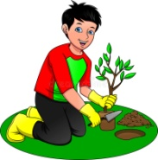
fly be ride do go stay plant
7 8 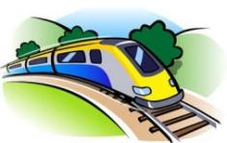9 10111213 
visit travel be at a live concert meet a celebrity cook win be
-Have you ever flown an airplane?
-Yes. I have! It was exciting! OR -No, I haven’t. I have never flown an airplane.
-Would you like to try?
-Yes, I think it must be exciting! OR No, I think it must be dangerous.

- Make similar conversations for all the situations. Use the words: exciting, fantastic, breathtaking, thrilling, interesting, fun, delicious, dangerous, boring, awful, disgusting, frightening, horrible

- Write sentences as in the example:
I have never flown an airplane and I wouldn’t like to fly one. It must be dangerous.
I have never been to China but I would like to go. It must be fantastic.
I have met a celebrity. It was exciting!

Household chores with just / already / yet

Mrs Brooks is a cleaning lady. Today, she’s cleaning the Browns’ house. Look at the pictures and say: what she has already done, what she has just done and what she hasn’t done yet.
1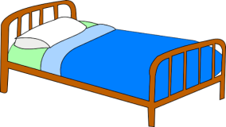2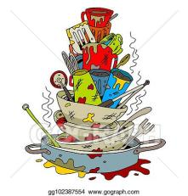3 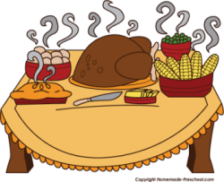 4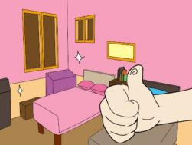5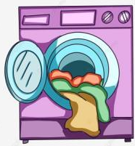 6
make do cook tidy do iron

7 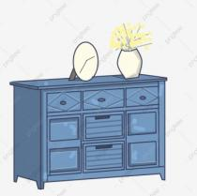 8  9 10 11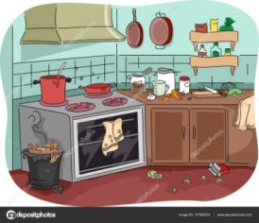 12
dust take out clean set clean mop
30

Present Perfect with for / since
Look at the pictures and use the clues to make sentences as in the example, using since or for.
1. Sue went to London last Monday. She is in London now. She has been in London since last Monday.
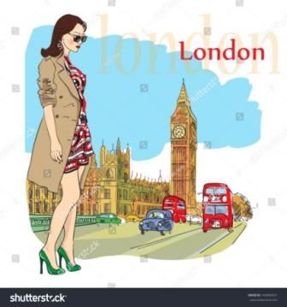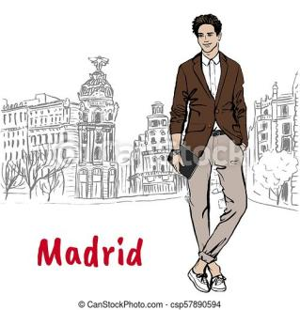
1. Sue / go / be / last Monday 2. Bill / go / be / 3 days ago 3.Helen and Fay / go / be / last week
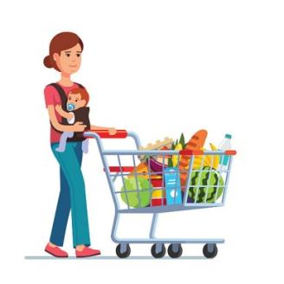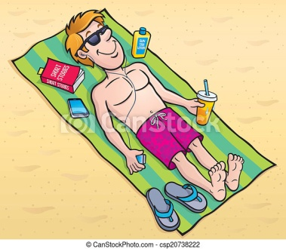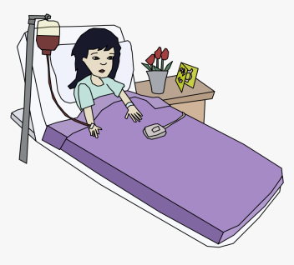
4. Mum / go / be / 2 hours ago 5.Ted / go / be / at 2:00pm 6.Clara / go / be / last week
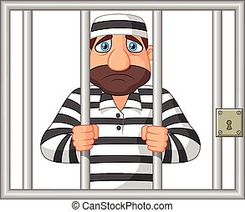
7.Sammy / go / be /in 2019 8.Nick / buy /have / yesterday 9. Lina / find / have / two days ago

I haven’t seen you for a long time!
(Present Perfect & Simple Past)
Make sentences for each picture as in the example:
1.Lisa went on holidays last summer. (When did she go? Last summer.)
Lisa hasn’t gone on holidays since last summer.

1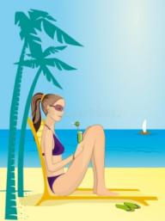 2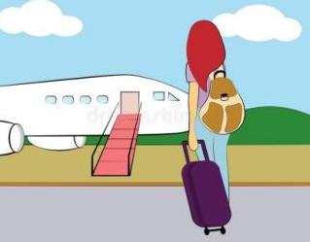 3 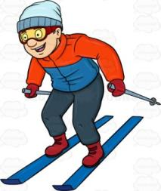 4  5 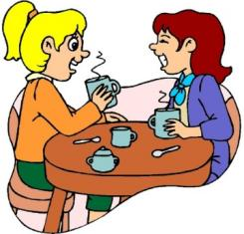
Lisa / go / last summer Fay / fly / in 2022 Bill / go/ last winter Tina / be / last year Flo and Jill / meet / last month
6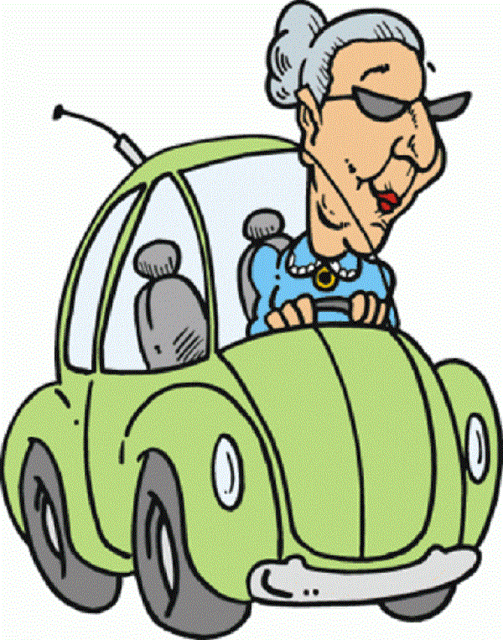 7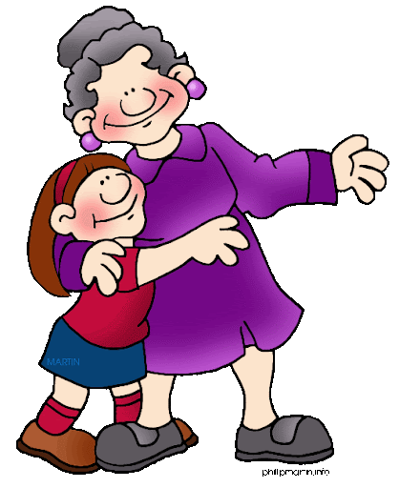 8 9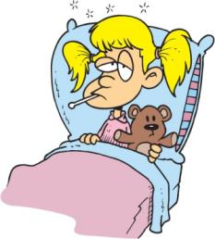 10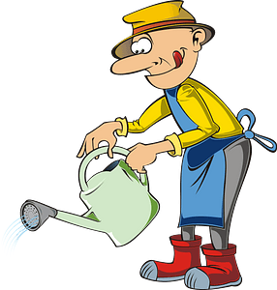
Lilly / drive / long ago Sue / see / a month ago Don / eat / 4 days ago Jo / be ill / 2 years ago Ben / water / 2 days ago
31
Present Perfect and Simple Past
When did you…. & How long have you…?
Look at the example and make similar conversations for the pictures based on the clues.
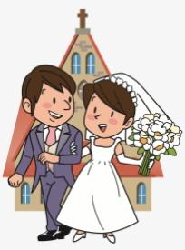
Jack and Jill / get / be / 5 years ago
Jack and Jill are married.
When did they get married?
They got married 5 years ago.
How long have they been married?
They have been married for 5 years.

1. 2.  3. 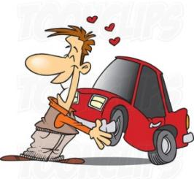 4. 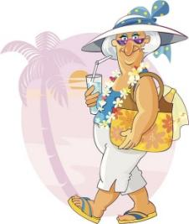
Seth has a beard. Gilda and Frida are friends. Rick has a new car. Maggie is on holiday
grow /have / last year become / know / a long time ago buy / have / a month ago go / be / last Sunday
5. 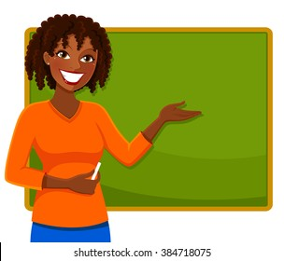 6. 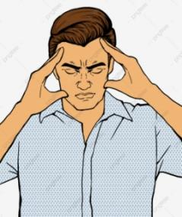 7. 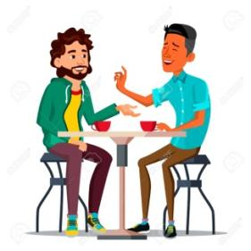 8. 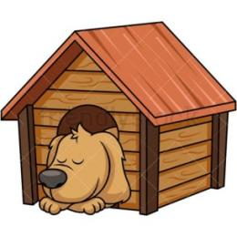
Anne is a teacher. Dean has a headache That’s my best friend Jim Rex has a new kennel
become/ be /7 years ago start having /have /an hour ago meet / be / at school have / last Monday
Present Perfect or Simple Past?
1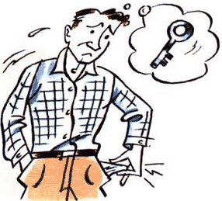2  3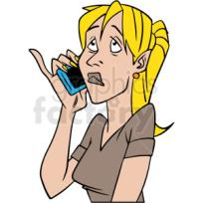45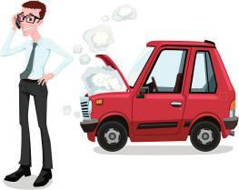6
7 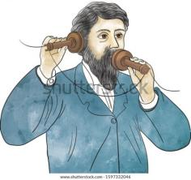 8 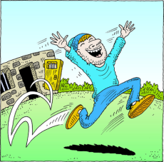 9  10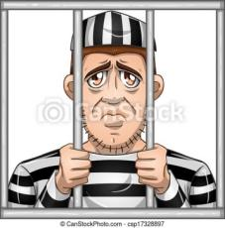 11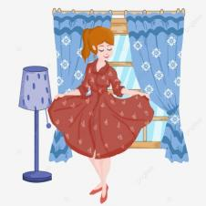 12
1.Tom can’t get into his house. He …………………………. (lose) his key.
2.The office is empty now. Everybody…………………………………. (go) home.
3. I wanted to call you last night but I ……………………….. (forget)
4.-Are you OK? -Yes, I ……………………………. (have) a headache, but I feel fine now!
5. -Yes please, can you help me? My car …………………………………… (break down)
6. Wow! We ..…………………………………. (win) the lottery.
7. Alexander Graham Bell ……………………. (invent) the telephone.
8. Rudy ……………………………. (be) in prison.
9. Oh no! I ……………………………… (cut) my finger. It’s bleeding!
10. Jake ……………………………………. (be) in prison for a year now.
11. I …………………………………… (buy) a new dress. Do you like it?
12. The weather ……………………………… (be) nice but now it’s raining. 32
A) Write a suitable sentence using the PRESENT PERFECT TENSE
1. Ann’s hair was dirty. Now it’s clean. (wash) ……... Ann has washed her hair………………………………………….……
2. Tom was 80 kg. Now he’s 70. (lose weight) ……………………………………………………………………………………….………..
3. Bill played football yesterday. Now his leg is in plaster. (break) …………………………………………………………………..
4. My sister is looking for her pen. (lose) ………………………………………………………………..………………………………………
5. Mary is on holiday in France. (go) ………………………………………………………………………….……………………………………..
6. Mr. Hill was in Canada last week. He’s back in London now. (be) ……………………………………………….…………………
7. Look! Mrs. Smith has got a lot of packages. (buy) ………………………………………………………………………………………….
8. I can’t eat anything now. (eat too much) …………………………………………………………………..…………………………………….

B) Fill in the blanks with ALREADY or YET:
1. He hasn’t called us ……………………………… .
2. They have ………………………………… sent the letter.
3. John has ……………………………… bought the tickets for the football match.
4. We have ……………………………….. been to Mexico three times.
5. You haven’t visited Tokyo ………………………………… .
6. Has John bought a new car ………………………………….. ?
7. The plane has …………………………… left.
8. Has she done it …………………………….. ? No, not …………………………. .

C) Put the verbs in the correct tense. Use the SIMPLE PAST or the PRESENT PERFECT:
1. ……………………….. Tim ………………………. (finish) his work yet?
2. ……………………….. he ………………………… (finish) it yesterday?
3. They ………………………..…………………………. (just / go) out.
4. They ……………………..…………………… (go) out a minute ago.
5. …………………… Ann …………………………. (study) yesterday afternoon?
6. ……………….……… you ……………………………. (send) the letters yet?
7. ……………………..… she …………..……………….. (call) him a week ago?
8. They ………………………………..……………………. (not / see) the film yet.
9. The train …………………………….………………………………… (just / arrive).
10. …………………………. you ……………………………. (ever / be) in a TV studio?
11. …………………… you and Tom …………………………..………………… (enjoy) the party last night?
12. …………………… you ………………………………. (not / finish) school last year?
13. I ………………………………………. (lose) my dictionary. I can’t find it anywhere.
14. His hair looks short. He ………………………………………………………………….. (have) a haircut.
15. When …………………………………………..…………………………. (he / give up) smoking?
16. Jane ………………………………..…………………….. (buy) her car two weeks ago.
17. My bicycle isn’t here. Somebody ……………………….…………………………………. (take) it.
18. Why ………………………………………….…………… (Jim / not want) to play tennis last Friday?
19. The car looks clean. ……………………….. you ……………………………….. (wash) it?
20. When we were on holiday, the weather …………………………………… (be) terrible.
D) Rewrite the following sentences twice, using SINCE and FOR:
Example: I haven’t seen you. (Christmas / 3 days)
a) I haven’t seen you SINCE Christmas. b) I haven’t seen you FOR 3 days.
1. We’ve been here. (an hour / 4 o’clock)
a) ………………………………………………………………………….… b) ……………………………………………………………………………
2. She hasn’t spoken to me. (2 weeks / last week)
a) …………………………………………………………………………..… b) ……………………………………………………………………………
3. They’ve lived in this street. (1970 / a long time)
a) ………………………………………………………………………… ….. b) …………………………………………………………………………
4. I haven’t had time to do it. (last Monday / a few days)
a) ………………………………………………………………………… …… b) …………………………………………………………………………
5. We haven’t bought a new one. (ages / many years)
a) ……………………………………………………………………………… b) …………………………………………………………………………….
33

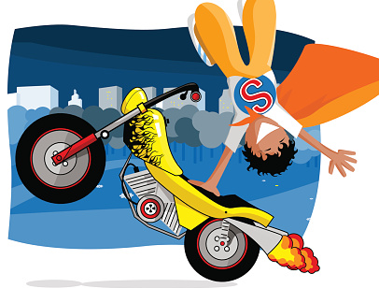
Let’s Read: Risky Jobs
How long have you been a stuntman?
I ‘ve been a stuntman for seven years!
What do you do in your job?
I perform stunts. For example, I jump off high buildings or running cars, I drive cars and motorbikes at very high speed or I go through fires!
When did you do your first stunt?
Seven years ago. I rode a motorbike down a mountain slope.
What is the most dangerous stunt you’ve ever done?
I jumped off a helicopter that was on fire!
Do you like your job?
I love it. Although it’s risky, I think it’s exciting!
RON WOOD-STUNTMAN
Ron Wood is a stuntman. He has been a stuntman for seven years. In his job, he performs stunts. For example, he jumps off high buildings or running cars, he drives cars and motorbikes at very high speed or goes through fires!
He did his first stunt seven years ago when he rode a motorbike down a mountain slope. The most dangerous stunt he’s ever done was when he jumped off a helicopter that was on fire! Ron loves his job. Although it’s risky, he thinks it’s exciting!

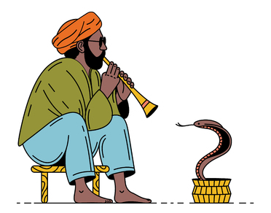
___________________________________________________
I ‘ve been a snake charmer since I was a kid!
___________________________________________________
I ‘m a street performer in India. I play the flute and make snakes come out of a pot and “dance”.
___________________________________________________
When I was eight years old. I made a cobra dance to the music of my flute!
___________________________________________________
The most dangerous performance was when I made a python dance! Pythons are huge snakes that can break your bones!
___________________________________________________
I love it. Although it’s dangerous, I think it’s mysterious!
RAVI SANDAR-SNAKE CHARMER
……………………………………………………………………………………………………………………………………………………………………………………………………………………………………………………………………………………………………………………………………………………………………………………………………………………………………………………………………………………………………………………………………………………………………………………………………………………………………………………………………………………………………………………………………………………………………………………………………………………………………………………………………………………………………………………………………………………………………………………………………………………………………………………………………………………………………………………………………………………………………………………………………………………………………………………………………………………………………………………
…………………………………………………………………………………………………………………………………………………………………………… 34

_______________________________________________
I ‘ve been a war photographer since 2017!
________________________________________________
I take pictures in war zones. Then, I upload the pictures and people can see that a war is a terrible thing.
________________________________________________
I took my first photo ten years ago. It was a child who lost his parents in war!
________________________________________________
The most dangerous picture was a bombing. I was nearly killed!
________________________________________________
I love it. Although it’s dangerous, I think it’s adventurous!

MAY WEST-WAR PHOTOGRAPHER
…………………………………………………………………………………………………………………………………………………………………………………………………………………………………………………………………………………………………………………………………………………………………………………………………………………………………………………………………………………………………………………………………………………………………………………………………………………………………………………………………………………………………………………………………………………………………………………………………………………………………………………………………………………………………………………………………………
……………………………………………………………………………………………………………………………………………………………………………………
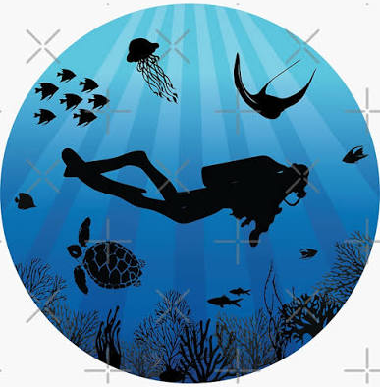
_______________________________________________________
I’ve been a deep-sea diver for five years!
_______________________________________________________
I repair underwater pipes and explore old shipwrecks deep in the ocean. I swim with dangerous sea creatures like sharks and giant squids!
_______________________________________________________
I did my first dive five years ago. I explored a sunken fishing boat near an island.
_______________________________________________________
I got trapped in a cave under the water when my flashlight stopped working!
_______________________________________________________
I love it! Although it’s dark and cold, I think it’s amazing!

LEO VANCE - DEEP-SEA DIVER
……………………………………………………………………………………………………………………………………………………………………………………………………………………………………………………………………………………………………………………………………………………………………………………………………………………………………………………………………………………………………………………………………………………………………………………………………………………………………………………………………………………………………………………………………………………………………………………………………………………………………………………………………………………………………………………………………………………………………………………………………………………………………………………………………………………………………………………………..
35
Let’s Learn: Proverbs

What is a proverb?
A proverb is folk wisdom or advice in short sentences. Most proverbs are local and reflect wisdom, beliefs, and traditions of the place, but some are global. The majority of them have been around for centuries – and even millenniums.

Look at the pictures A-J and try to imagine if they bring you in mind any Greek proverbs. Then match them with the English proverbs 1-10.
A B C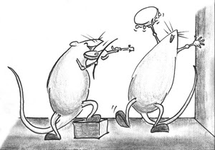 D E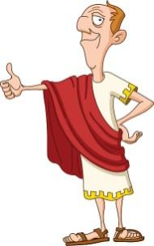F G 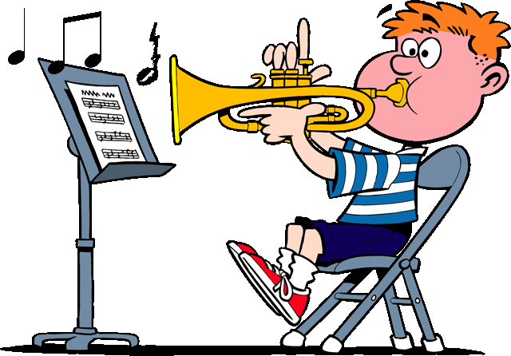H  I  J 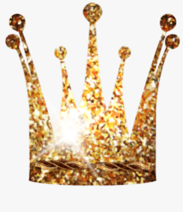

A leopard doesn’t change its spots.

All is well that ends well.

All that glitters is not gold.

An apple a day keeps the doctor away.

Barking dogs seldom bite.

Fortune favors the brave.

Money doesn’t grow on trees.

Practice makes perfect.

When in Rome, do as the Romans do.

While the cat is away, the mice will play.

Now try to match the proverbs with their meanings a-j.
- If you carry out your plans boldly, luck is more likely to be with you.
- When the outcome is good, problems on the way don’t matter.
- When you visit a foreign land, follow the customs of local people.
- People can’t change their character, especially when they‘re bad.
- People often break the rules when no one watches over them.
- Eating an apple a day will keep you healthy.
- When you do something over and over, you become better at it.
- Things that look good outside, may not be valuable.
- Spend money carefully because you can’t grow it like apples.
- People who appear threatening rarely do harm.

Try to say the proverbs by only looking at the pictures. Then, in pairs find more proverbs in English and tell them in class. Ask your classmates to tell their meaning.

36

Let’s remember: Tenses, comparisons & prepositions
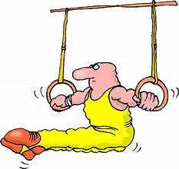
1. Write the questions. Use WHEN, WHERE, WHO or WHAT:
1. A: We went to California on our vacation.
B: Really? …. Where did you stay…………………… (you / stay)?
A: In a hotel in Santa Monica.
2. A: The children visited the usual tourist attractions.
B: Oh, yeah? …………………………………………….. (they / see)?
A: Oh, they went to Disneyland, the San Diego zoo, and a movie studio.
3. A: My wife played a lot of tennis.
B: ……………………………………………………….. (she / play) with?
A: She played with our oldest son.
4. A: I really enjoyed the trip. We even stayed a few extra days.
B: ……………………………………………………….. (you / plan) to come home?
A: Well, we planned to come home on Monday, but we didn’t get back until Friday.

2. Complete the sentences. Use SIMPLE PRESENT, PRESENT CONTINUOUS, or SIMPLE PAST.
1. I ……………………….. (get) up at eight o’clock yesterday morning.
2. Mark …………………………….. (talk) to John on the phone last night.
3. Mark …………………………….. (talk) to John on the phone right now.
4. Mark …………………………….. (talk) to John on the phone every day.
5. Jim and I ……………………. (eat) lunch at the cafeteria two hours ago.
6. We ……………………………. (eat) lunch at the cafeteria every day.
7. I …………………………. (go) to bed early last night.
8. My roommate ………………………….. (study) Spanish last year.
9. Sue ………………………….. (write) a letter to her parents yesterday.
10. Sue ………………………….. (write) a letter to her parents every week.
11. Sue is in her room right now. She …………………………. (sit) at her desk. She …………………………………. (write) a letter to her boyfriend.
12. Marianne ……………………… (do) her homework last night.
13. Yesterday I ………………………. (see) Dave at the library.
14. I ……………………… (have) a dream last night.I ……………………….. (dream) about my friends. I …………………………. (sleep) for eight hours.
15. Alice ……………………… (smoke) a cigarette after class yesterday.
16. My wife ………………………….. (come) home around five every day.
17. Yesterday she …………………………… (come) home at 5:15.
18. Our teacher ………………………………… (stand) in the middle of the room right now.
19. Your teacher …………………………….. (stand) in the front of the room yesterday.
20. John usually ………………………. (sit) in the back of the room, but yesterday he ………………………… (sit) in the front row. Today he ………………. (be) absent. He ………………….. (be) absent two days ago too.

37
3. Use THE SIMPLE PAST or THE PRESENT PERFECT to fill in the blanks:
1. What ………………………………………… (you / learn) since you …………………….(come) here? How many friends ……………………….………. (you / make)? I hope you …………………………………... (already / meet) a lot of interesting people.
2. Last night my roommate and I …………………………….. (have) some free time, so we ………………………….. (go) to a show.
3. I ………………………………..………….. (just / have) lunch, but I ………………………………………(not / have) lunch yesterday.
4. Who ……………………………………………………………. (write) the play “Hamlet”?
5. How many games ……………………………………………………… (the team / win) so far this season?
6. I don’t know Carol’s husband. I ……………………………………………………………. (never / meet) him.
7. It ……………………………………………(rain) a lot last week, but it …………….………………… (not / rain) much so far this week.
8. How many letters ……………………………………………….. (you / write) since the beginning of the month?
9. When we were on vacation, the weather ………………………….………………………… (be) terrible.
10. In her whole lifetime, Mary …………………………………….………………………… (never / see) snow.
11. I don’t know where Ammy is. ……………………………………………..………………………….(you / see) her?
12. When I ……………………………….………………. (get) home last night, I ……………………….. (be) very tired and I …………………………… (go) straight to bed.
13. Your car looks very clean. ……………………………………..……………………………. (you / wash) it?
14. George ……………………………………………………..……………….. (not / be) very well last week.
15. Mr. Clark …………………………………………..……………………… (work) in a bank for 15 years. Then he gave it up

4. Fill in the blanks as in the example:
I went on holiday last year but it was a disaster! My hotel room was .. smaller than … (small) the one in the photograph in the brochure. I think it was …………………………….……… (small) room in the hotel. The weather was terrible too. It was ……………………………….…… (cold) in England. The beach near the hotel was very dirty – it was …………………………………… (dirty) all the beaches on the island. The food was …………………………………………. (expensive) I expected and I didn’t have enough money. One day I went shopping in a big department store and I broke a vase. It was …………………………………………………… ( expensive) vase in the whole shop. But …………….……………………………. (bad) thing all was that I lost my passport and I couldn’t go back home. It was …………………………………………….. (horrible) holiday all my life.

5. Put in the correct prepositions AT / ON / IN:
1. Columbus discovered America …………… 1492.
2. You can see the stars …………… night, if the sky is clear.
3. Tom isn’t here …………. the moment. He’ll be back …………. five minutes.
4. The course begins ……….. 7 January and ends ………… 10 March.
5. Tom’s grandmother died ……….. 2017 ……….. the age of 79.
6. The price of electricity is going up …………. October.
7. Ann works hard during the week, so she likes to relax …………. weekends.
8. I can’t be at home ………… the morning. Can you phone me ………. the afternoon instead?
9. Jack’s brother is an engineer but he’s out of work ……….. the moment.
10. …………. Sunday afternoons I usually go for a walk in the country.
11. Tom doesn’t see his parents very often these days- usually only ……….. Christmas ,and sometimes …………. the summer for a few days.
38

